ECSE Capstone Final Report
Team #6
Semester 1, 2026

Table of Contents
Acknowledgements 4
Executive Summary 4
1.0 Introduction 5
1.1 Problem Definition 5
2.0 Project Delivery 6
2.1 Requirements and Stakeholders 6
2.2 Team Structure and Roles 6
2.3 Tasks and Work Division 6
2.4 Milestones 7
3.0 Technical Solution 7
3.1 System-Level Design 7
3.2 Electrical Design 8
3.2.1 Overview of Electrical Requirements 8
3.2.2 Signal Conditioning Architecture 8
3.2.3 Voltage Sensing 9
3.2.4 Bidirectional Current Sensing 9
3.2.5 PCB Design and Component Selection 10
3.2.6 Calibration and Validation 10
3.3 Computer Systems Design 11
3.3.1 System Architecture Overview 11
3.3.2 ADC Sampling and Signal Processing 12
3.3.3 ESP-NOW Communication Architecture 12
3.3.4 Power Saving Mode 13
3.3.5 Local Data Storage During 14
3.3.6 Time Synchronisation (Team-Designed Feature) 14
3.3.7 Error Handling and Reliability 15
3.4 Software Design 15
3.4.1 System Architecture Overview 15
3.4.2 Backend Design 16
3.4.3 Database Design 17
3.4.4 Frontend Design 17
3.4.5 Feature 6: Multi-Team Comparison Dashboard (Team-Designed Feature) 18
3.4.6 Power Limit Detection (Feature 4) 18
3.4.7 Development Workflow and CI 19
3.4.8 Software Bill of Materials 19
3.4.9 Software Future Design Plans 20
3.5 Solution Cost and BOM 20
4.0 Business Value of the Solution 21
4.1 Value to EVolocity and Event Administrators 21
4.2 Value to Competing Teams and Students 21
4.3 Unique Value and Points of Difference 22
4.4 Cost and Bill of Materials 22
4.5 Sustainability 22
4.6 Data Sovereignty and Privacy Regulatory Compliance 24
4.7 Radio Regulatory Compliance 25
4.8 Te Tiriti o Waitangi 25
5.0 Conclusions 26
5.1 Summary of Achievements Against Client Requirements 26
5.2 Planned Future Work 28
Appendices 30

Acknowledgements
This report acknowledges the use of AI tools, to support the structuring and refinement of written content throughout the report. All technical design decisions, implementation work, and analysis were carried out by the team. We also thank Keith Anderson and the EVolocity team for their time and willingness to engage with our questions, particularly during the client meeting in Week 8, which gave us valuable clarity on real-world race day workflows and scoring requirements.

Executive Summary
Team 6 has designed and built a prototype Energy Control Unit (ECU) system for EVolocity, replacing the current manual USB-C data retrieval process with a fully automated wireless solution. The system comprises three integrated components: a custom-designed printed circuit board for analogue signal conditioning, an ESP32 microcontroller for data acquisition and wireless transmission and a browser-based software dashboard hosted locally on a Windows laptop at no ongoing infrastructure cost.
The hardware measures battery voltage across the full 18-60V competition range and bidirectional current up to ±100 A, including energy recovered through regenerative braking. Both measurements were validated to within ±2.5% of calibrated bench equipment and within ±0.5% between the two prototype units, satisfying EVolocity's inter-unit accuracy requirements.
Each ECU continuously writes samples into a local circular buffer sized to store a minimum of five minutes of data. If an ECU moves out of range of the controller, as can happen on long tracks or in areas of radio interference, data continues to be recorded locally and the full backlog is transmitted automatically at maximum rate once the ESP-NOW link is re-established, ensuring no race data is lost to temporary disconnections. To preserve the chronological integrity of buffered records, there is a time sync mechanism between the backend server, ESP-NOW controller and sender, ensuring data stored during a disconnection is correctly ordered when it arrives.
The software dashboard implements all six required features: team and competition management, live and historical data display, power limit alerts, an energy efficiency leaderboard, and a multi-vehicle comparison view that allows officials to monitor all competing vehicles side by side in real time. This final feature directly addresses a supervision gap identified during the client meeting and represents a point of difference beyond the minimum specification.
The solution is designed with EVolocity's operational context in mind and deeply considers New Zealand broader goals around electric vehicle adoption and STEM education for rangatahi. All competition data is processed and stored locally on self-hosted hardware at the race venue, with no dependency on internet connectivity or third-party cloud services. This approach ensures compliance with the New Zealand Privacy Act 2020 and addresses data sovereignty obligations so that the competitor data, remains under EVolocity's direct control at all times. The local-first architecture also ensures the system continues to function reliably at remote venues where cellular and internet connectivity are limited. From a sustainability perspective, the design prioritises component reuse, low standby power consumption through the ESP32's modem-sleep capability, and an offline software stack that carries no ongoing infrastructure cost. Furthermore, the ESP32's 2.4 GHz Wi-Fi module operates within New Zealand's general user radio licence framework, meaning no individual radio licence is required for deployment at competition venues.
The estimated unit cost is approximately $29.97 NZD, covering the custom PCB and ESP32 module. All software infrastructure runs at zero ongoing cost on self-hosted hardware. Further detail on the bill of materials, technical design, and business value is provided in Sections 3 and 4.

1.0 Introduction
EVolocity is a New Zealand STEM programme where intermediate and high school students design, build, and race electric vehicles over the course of a year. The programme culminates in Regional Finals, where teams compete across several dynamic and static events including drag racing, gymkhana, and an endurance & efficiency competition. Scoring the events requires precise energy measurement from each competing vehicle. Currently this is done by physically connecting a USB-C cable to each ECU at the end of a race to view race data. As the number of competing teams grows, and as vehicle configurations increasingly include regenerative braking, this process presents two compounding problems of a race-day bottleneck as officials work through each vehicle individually, and a fairness issue where unidirectional current measurement fails to account for energy recovered during braking.
Team 6 was engaged by EVolocity to address both problems. The resulting prototype replaces manual USB data retrieval with a fully wireless telemetry system, introduces bidirectional current sensing to measure net energy consumption accurately across all vehicle configurations, and delivers a software dashboard that gives event administrators real-time visibility across all competing vehicles simultaneously.
This report documents the complete implemented solution. Section 2 summarises how the project was delivered, including team structure and key milestones. Section 3 presents the technical detail of the electrical hardware, embedded firmware, and software components. Section 4 describes the business value of the solution for EVolocity and its broader stakeholders, covering sustainability, data sovereignty, and regulatory obligations. Section 5 draws conclusions and outlines the path toward deployment.

1.1 Problem Definition
The data retrieval bottleneck has been a known limitation since EVolocity developed its first ECU iteration in 2022. As described by EVolocity in the Week 1 client lecture, the original motivation for building the ECU was that scoring took too long, power violations were going undetected, and there was no reliable way to measure energy for the efficiency event. The USB-based system was a necessary starting point, but as participation has grown it has become increasingly untenable: at the end of the race, all vehicles are held in parc ferme while an official works through them one by one, and results cannot be finalised until every ECU has been physically accessed. There is no central visibility during the race itself, and because data is only accessible after manual retrieval, power limit violations cannot be identified or acted on until after the event has concluded.
A related problem concerns the accuracy of efficiency scoring. As confirmed by EVolocity's Technical Lead during Client Meeting 2, the efficiency event requires energy to be calculated only within each team's active race window, defined by a start time and race duration. This depends on each ECU's internal clock remaining synchronised with the central scoring system throughout the race day. ECUs that go offline and reconnect are vulnerable to clock drift, which can result in the wrong energy window being used for scoring. This is a subtle but consequential source of unfairness that is difficult to detect and correct after the fact.
The fairness problem has emerged more recently as a consequence of improving vehicle technology. Teams in the Open Class have begun incorporating regenerative braking, which returns energy to the battery during deceleration. Because the current ECU measures current in only one direction, these teams cannot be scored correctly without manual post-race correction. As EVolocity confirmed in Client Meeting 2, recovered energy had to be calculated separately and subtracted by hand. Beyond the administrative burden, this creates a structural disincentive against adopting more efficient drivetrain designs, directly undermining EVolocity's goal of rewarding innovative and energy-conscious engineering.
All three problems were raised by EVolocity as motivating this project.

2.0 Project Delivery

2.1 Requirements and Stakeholders
EVolocity engaged Team 6 to design and build a prototype next-generation energy monitoring system. The core requirements were to replace the current manual USB-C data retrieval process with a wireless solution, extend current sensing to support bidirectional measurement for vehicles using regenerative braking, and provide a software dashboard allowing event administrators to monitor and configure all active energy monitors from a single screen. The system was required to maintain data integrity during wireless outages, operate continuously for at least 4.5 hours without physical intervention, and run entirely on self-hosted hardware at zero ongoing software cost. The primary stakeholder is EVolocity, whose event administrators are the intended daily users of the system. Secondary stakeholders include competing student teams, whose scores depend on accurate and fair energy measurement, and their teachers and pit crews, who stand to benefit from live visibility into their vehicle's performance during a race. The University of Auckland is also a key stakeholder as a long-term collaborator and financial sponsor of the EVolocity programme.

2.2 Team Structure and Roles
Team 6 was organised into three sub-teams: electrical (Eric and Jevaan), computer systems (Joe and Zhiyuan), and software (Jerry, Shihoo, Ajith, Bailey, and Oshan). Zhiyuan served as overall team lead. Ajith, Zhiyuan, and Jevaan led their respective sub-teams on technical decisions.

2.3 Tasks and Work Division
Each sub-team owned its workstream end to end: electrical covered circuit design, board fabrication, and accuracy validation; computer systems covered microcontroller programming, wireless communication, and local data storage; and software covered the backend server, database, and dashboard. An integration workstream ran across all three, verifying the complete system worked together under realistic conditions.
Progress was tracked using GitHub for code management and Trello for higher-level planning (Figure C2). All code changes went through peer review before merging, with automated checks catching issues beforehand. A full project schedule is included in Appendix C (Figure C1) as a historical record.

2.4 Milestones
The project was delivered through three assessed milestones leading to the final demonstration. Milestone 1 in Week 5 confirmed that data could be transmitted end-to-end from the microcontroller to the browser dashboard in real time. Milestone 2 in Week 8 demonstrated two working circuit boards meeting EVolocity's accuracy requirements, along with a power saving mode and two software features. The final demonstration in Week 11 presented the complete integrated prototype covering all electrical, firmware, and software requirements.

3.0 Technical Solution

3.1 System-Level Design
The prototype consists of three integrated subsystems: an electrical hardware layer, an embedded firmware layer, and a software layer. Together they form a continuous data pipeline from vehicle battery terminals to a browser-based dashboard running on the event operator's laptop.
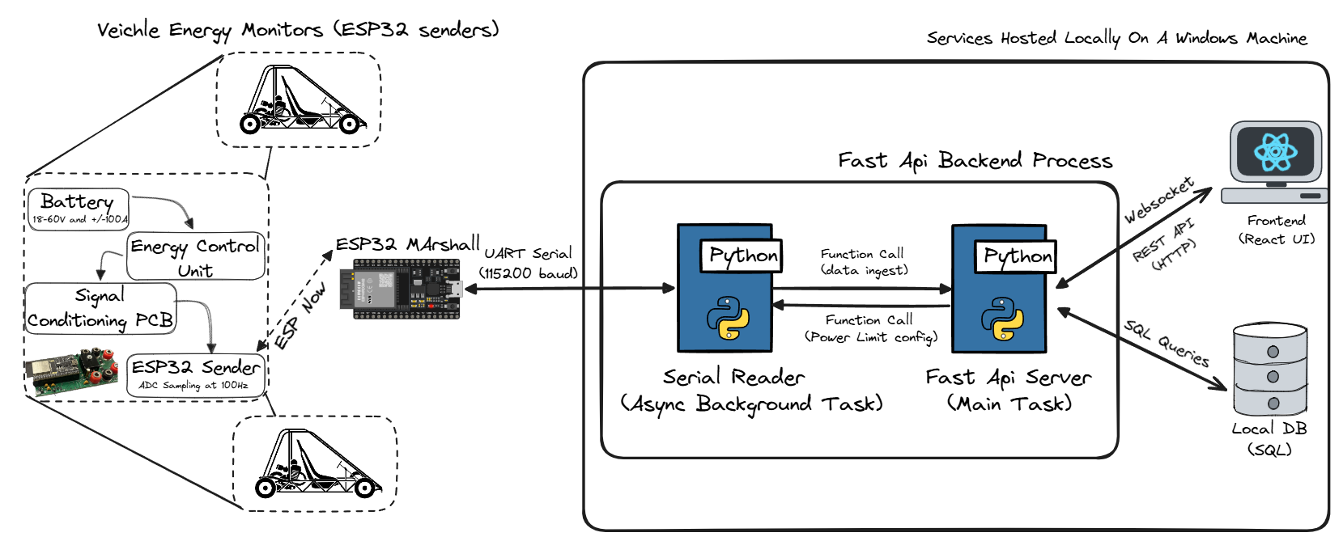
Figure 1: System-level architecture diagram showing the three subsystems and the interfaces between them
Electrical Hardware: Each vehicle carries a custom PCB that connects between the battery and motor controller. The board conditions the raw battery voltage (18 to 60 V) and bidirectional current (up to 100 A in either direction) into analogue signals compatible with the ESP32 ADC input range. It also provides a buzzer for on-device power limit alerts, LED indicators for battery voltage status, a relay control stage, and calibration jumpers that allow the firmware to identify which board it is running on and apply the correct per-unit calibration constants. Each PCB hosts an ESP32 DevKitC module, which handles all sampling, storage, and wireless communication.
Embedded Firmware: The ESP32 on each ECU runs FreeRTOS firmware that samples the conditioned ADC signals at 100 Hz, buffers frames in RAM and on SPIFFS flash, and transmits data wirelessly to a dedicated controller ESP32 using the ESP-NOW protocol [Figure 1]. A separate controller ESP32, connected to the operator's laptop via USB, acts as a bridge: it receives ESP-NOW packets from all active ECUs, forwards the data to the backend over UART at 115,200 baud, and relays time synchronisation and power limit commands from the backend back to individual ECUs. The two-device architecture avoids requiring each ECU to run a full WiFi IP stack, reducing connection overhead and allowing low-latency transmission without network association delays.
Software: The backend is a FastAPI application running locally on the operator's laptop. A serial reader module ingests frames from the controller over UART and feeds them into the database and live broadcast channels. REST endpoints serve historical data, team and competition configuration, and firmware management. WebSocket channels push live energy frames and violation events to connected browser clients in real time. The React frontend connects to these endpoints to display live telemetry, historical data, power limit alerts, and the multi-team comparison dashboard across all active ECUs simultaneously.
Data Flow: Raw analogue signals from the vehicle battery are conditioned by the PCB and read by the ESP32 ADC at 100 Hz. Each sample is calibrated, timestamped, and written into a local buffer. The sender task batches samples into ESP-NOW packets and transmits them to the controller, which forwards each frame to the backend over UART. The backend processes each frame, persists it to the SQLite database, runs violation detection, and broadcasts it to all subscribed WebSocket clients. The frontend receives frames in real time and renders them on the dashboard.
Interface Summary: The key interfaces between subsystems are: the ADC analogue interface between the PCB signal conditioning circuit and the ESP32 (Channels 4, 6, and 7 on ADC Unit 1); the ESP-NOW wireless link between ECU and controller ESP32s operating on the 2.4 GHz band; the UART serial link between the controller ESP32 and the backend at 115,200 baud; the REST API between the frontend and backend for configuration and history retrieval; and the WebSocket channels between the backend and frontend for live frame and violation event delivery.
Cost: The estimated cost per ECU unit is approximately $29.97 NZD. The full itemised Bill of Materials is provided in Section 3.5. All software infrastructure runs at zero ongoing cost, consistent with EVolocity's requirement for a $0 software budget, as the backend runs on the operator's existing Windows laptop with no cloud services or paid dependencies.

3.2 Electrical Design

3.2.1 Overview of Electrical Requirements
The electrical subsystem measures vehicle energy by conditioning the battery voltage (18–60 V) and bidirectional current (±100 A, including regenerative braking) into signals compatible with the ESP32 ADC. The design targets ±2.5% measurement accuracy and ≤±0.5% unit-to-unit variation, ensuring accurate net energy measurement and fair competition evaluation across all participating vehicles. To satisfy these requirements, the ADC is configured with 12 dB attenuation, giving an effective input range of 150 mV to 2.45 V at 12-bit resolution (see Appendix Figure B1). All signal conditioning circuitry is implemented on a custom PCB designed in Altium Designer.

3.2.2 Signal Conditioning Architecture
The circuit (see Appendix Figure A1) implements two independent signal paths from the battery terminals to the ESP32 ADC. The voltage path attenuates the battery voltage through a resistive divider, isolates it with a unity-gain op-amp buffer, and passes it through a first-order RC low-pass filter before reaching the ADC pin. The current path amplifies the millivolt-level shunt voltage with a non-inverting op-amp gain stage, adds a mid-rail reference offset so that zero current maps to ADC mid-scale, and similarly filters the output. A block diagram of both signal conditioning paths is shown in Figure A3. Additional on-board subsystems include a 12 V to 5 V linear regulator (L7805CV), a 5 V relay control driver stage, battery-voltage indicator LEDs (green/red), a buzzer for penalty alerts, calibration select jumpers (Cal_Select_1 and Cal_Select_2), and a test-point measurement header (J7–J12) for bench verification.

3.2.3 Voltage Sensing
Battery voltage is attenuated from the 18–60 V range to the 0–2.45 V ADC input range using a resistive voltage divider. The top leg combines a 220 kΩ and 22 kΩ resistor in series (R_top = 242 kΩ) with R_bottom = 10 kΩ, giving a divider ratio of 10k / (242k + 10k) = 0.0397. This scales 60 V to approximately 2.38 V, leaving ~25% headroom to allow detection of back-EMFs up to ~80 V. High-value resistors were selected to minimise quiescent current through the divider. The theoretical conversion from ADC voltage to battery voltage is V_bat = 25.19 × V_adc,V; after bench calibration against a reference supply this was refined empirically to V_bat = 24 × V_adc,V to account for resistor tolerance and ADC non-linearity.
A unity-gain LM324AM/NOPB buffer stage follows the divider to prevent the ADC from loading the voltage divider network. Using the worst-case LM324 input bias current of 500 nA, the loading error across the 9.6 kΩ Thévenin equivalent source resistance is less than 5 mV, well below the ±2.5% accuracy target. Resistor values in the MΩ range were avoided as higher source impedances increase susceptibility to bias-current error. A first-order RC low-pass filter (R = 1 kΩ, C = 100 nF) follows the buffer, giving a −3 dB cutoff frequency of f_c = 1/(2πRC) ≈ 1.59 kHz (see Figure B3). The relatively low cutoff was deliberately chosen to aggressively attenuate PWM-band and high-frequency switching interference; energy measurements are near-DC signals so no meaningful information is lost below this threshold. The capacitor also acts as a bypass capacitor on the ADC pin as recommended by Espressif’s ADC documentation.

3.2.4 Bidirectional Current Sensing
Current is measured using a low-side shunt resistor network placed in series with the battery return path. The network comprises three 1 mΩ resistors: R1 in series with the parallel combination of R2A and R2B, giving a total effective resistance of 1 mΩ + 0.5 mΩ = 1.5 mΩ. Low-side placement keeps the common-mode voltage near ground, avoiding the need for a high-side differential topology. At 100 A the shunt drops only 0.15 V and dissipates 22.5 mW — less than 0.084% of total system power at 60 V. A diode-based bidirectional method was considered and rejected due to dead-zone non-linearity around 0 A introduced by the forward-voltage drop.
The shunt signal feeds two parallel LM324AM/NOPB amplifier stages for different current ranges. The main path (U1C, ±100 A range) uses a non-inverting configuration with a combined feedback resistance of Rf = R15A + R15B = 68 kΩ + 6.8 kΩ = 74.8 kΩ and Rg = R13 = 10 kΩ, yielding a voltage gain of 7.44. The low-range path (U1B, ±10 A range) uses the same topology with Rf = 82 kΩ and Rg = 10 kΩ, giving a higher gain of 8.2 to improve resolution at small currents. Both stages sum a mid-rail reference voltage (V_ref ≈ 1.225 V) at the non-inverting input so that zero current maps to ADC mid-scale, allowing positive (motoring) and negative (regenerative braking) currents to be represented within the 0–2.45 V ADC window. Each path is followed by a first-order RC low-pass filter (R = 1 kΩ, C = 100 nF, fc ≈ 1.59 kHz; see Figure B3) before the respective ESP32 ADC pin — the main path to Channel 4 and the low-range path to Channel 7.
V_ref is generated by the on-board current offset reference generator (U1D, LM324AM/NOPB): a resistor voltage divider of R17 = 33 kΩ in series with the parallel combination of R18 = 100 kΩ and R19 = 12 kΩ, fed from the 5 V supply rail and buffered by a LM324 unity-gain follower, giving V_ref = 5 × (R18∥R19) / (R17 + R18∥R19) = 5 × 10.71 / 43.71 ≈ 1.225 V nominal.
For nominal component values the theoretical transfer equations are: main range V_adc,I = 0.01116 × I_bat + V_ref (reverse: I_bat = 89.6 × (V_adc,I − V_ref)); low range V_adc,I = 0.0123 × I_bat + V_ref (reverse: I_bat = 81.3 × (V_adc,I − V_ref)). In practice, empirically calibrated constants replace these nominal values — the derivation and firmware implementation are described in Section 3.2.6 and Section 3.3.2 respectively.

3.2.5 PCB Design and Component Selection
Two identical PCBs (referred to as the red and green boards) were fabricated and hand-assembled. The full circuit schematic is shown in Appendix Figure A1 and the PCB top-layer layout in Appendix Figure A2. The layout was designed in Altium Designer; the single A4 schematic sheet encompasses 14 functional blocks: the low-side shunt and current sense amplifier, main current sense amplifier, low-range current conditioning amplifier, current offset reference generator, voltage sense conditioning, battery voltage indicator, 12 V to 5 V linear regulator, 5 V relay control and driver stage, penalty control and 5 V LED indicators, 5 V buzzer control circuit, calibration select jumpers, test-point/measurement header, and the ESP32 interface I/O mapping. The PCB layout places power components and connectors around the board perimeter, with the ESP32 header centred to minimise trace lengths on high-frequency ADC signal lines.
The LM324AM/NOPB quad op-amp was selected over the TLC082 and LT6221 alternatives. The TLC082 was rejected for poor common-mode rejection at low shunt voltages below 0.3 V. The LT6221 performed well but at approximately $15 per unit across three required packages it was cost-prohibitive. The LM324’s quad package reduces PCB footprint, and its single-rail operation with good low-voltage performance near the ground rail meets the requirements for both the voltage buffer and current amplifier stages (Appendix Figure B2). The LM358BIDR dual op-amp is used in the relay control circuit as an overcurrent comparator: it compares the raw shunt voltage against a threshold set by a precision resistor divider (R31 = 96.7 kΩ, R32 = 3.01 kΩ) from the 5 V supply, tripping the relay at approximately 100 A — corresponding to the 0.15 V shunt voltage at the design current limit. Total component cost per ECU unit is approximately $29.97 NZD, with the electrical sensing hardware accounting for approximately $17 of that figure.

3.2.6 Calibration and Validation
Because component tolerances and PCB polygon pour parasitic resistance cause both boards to deviate from the theoretical transfer functions, each board was individually calibrated on the bench. The ADC first applies the ESP-IDF hardware calibration framework to convert raw counts to millivolts, correcting for ESP32 ADC non-linearity. A second empirical linear stage is then derived per board: with no current flowing, the ADC voltage is recorded as the board’s personal V_ref; a calibrated power supply then steps current in 0.05 A increments while ADC readings are logged, and the empirical gain G is derived from the slope of the resulting V vs I data. This process is performed independently for both the main (±100 A) and low-range (±10 A) current channels. The resulting constants — G and V_ref per channel per board — are stored in firmware. The exact firmware equations and channel assignments are documented in Section 3.3.2.
Validation confirmed both boards met the ±2.5% accuracy target across the 25–60 V, 1–3 A test range (see Figure A4). Below 25 V, current measurement error rises to approximately 6%, consistent with ADC non-linearity at the lower end of the input range; this is acceptable as EVolocity vehicles nominally operate above 25 V during competition. The calibration select jumpers (Cal_Select_1 and Cal_Select_2) allow the firmware to identify each board at runtime and apply its respective constants without separate firmware builds.
An automatic self-calibration circuit was designed and its PCB footprint included in the layout to allow future in-situ gain correction without a bench reference. Component procurement delays meant it could not be populated within the project timeline; the footprints remain available for future iterations.

3.3 Computer Systems Design

3.3.1 System Architecture Overview
The embedded firmware is built on FreeRTOS using the ESP-NOW protocol, with one controller ESP32 remotely connected to several ECUs. The sender ECU follows a producer-buffer-transmitter architecture. Three primary tasks handle distinct responsibilities: adc_task samples the ADC at 100 Hz and writes calibrated readings into an intermediate ring buffer, sender_task drains this ring buffer into a RAM-based circular transmission queue while simultaneously persisting frames to SPIFFS flash storage and managing ESP-NOW packet transmission, and buffer_monitor_task logs buffer status during disconnection periods. On the controller, a hello task broadcasts discovery packets at regular intervals so sender ECUs can locate and register with the network. When a REGISTER packet is received, the controller responds with a WELCOME packet containing the synchronised timestamp, starting the data stream. A UART listener task runs in parallel, receiving power limit commands from the Python backend and forwarding them to the target sender over ESP-NOW. A watchdog task monitors the last-seen time of each registered node and marks them as disconnected if no data is received within the timeout window.
This separation ensures ADC sampling is never blocked by network conditions. Even during a full disconnection between controller and sender ESP32s, adc_task continues running and writing to the transmission buffer, which is persisted to SPIFFS flash so that data survives unexpected reboots.
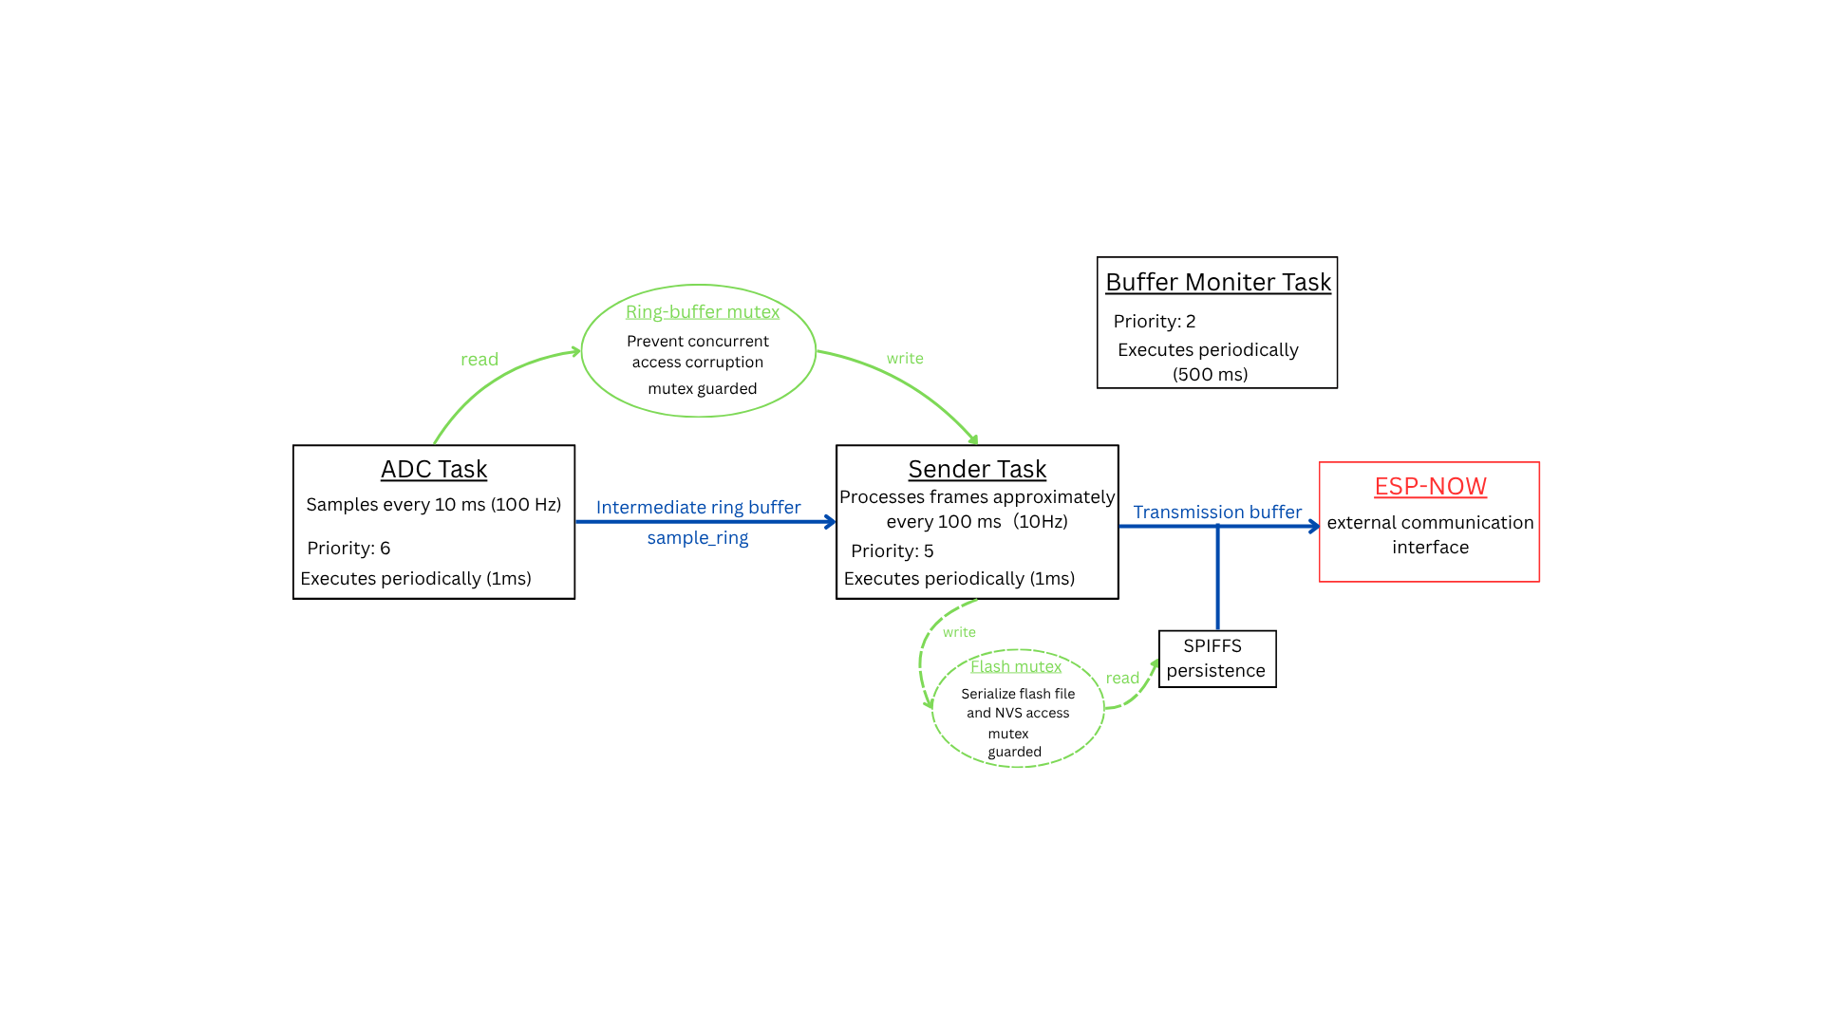
Figure 2: FreeRTOS task block diagram showing adc_task, sender_task, buffer_monitor_task on the ECU and their interactions with the ring buffer, SPIFFS, and ESP-NOW layer

3.3.2 ADC Sampling and Signal Processing
Two ADC channels on ADC Unit 1 are used for current sensing and one for voltage sensing. A dual-range approach is implemented for the current measurement: Channel 7 provides the primary low-range reading, and if that reading rises above 3000mV (10A equivalent), Channel 4 provides a high-range reading. This system was chosen to preserve high resolution and accuracy at low current readings while enabling detection of power spikes at higher current values. Channel 6 is used for voltage sensing.
All ADC channels are configured with 12 dB attenuation, providing an effective input range of approximately 150 mV ~ 2450 mV at 12-bit resolution. Raw ADC readings are calibrated to millivolts using the ESP-IDF calibration framework, with curve fitting used where supported by the hardware and line fitting otherwise. A second stage of empirically derived linear scaling is then applied to convert calibrated voltages into real-world current and voltage measurements.
Signal | Formula
Current, low range | real_current_mA = (int32_t)(mv_c × 5.57 − 6792)
Current, high range | real_current_mA = (int32_t)(mv_c × 80.7 − 102649)
Voltage | real_voltage_mV = (int32_t)(mv_v × 25 + 52)
Table 1: ADC Signal Conversion Formulas
The ADC acquisition task samples at 100 Hz, with calibrated readings written into a mutex-protected intermediate ring buffer before being batched into transmission frames by the sender task. The intermediate ring buffer decouples high-frequency ADC sampling from wireless transmission and flash operations, preventing temporary communication delays from affecting deterministic sampling behaviour. A mutex is used to protect the shared buffer from concurrent access by the sampling and transmission tasks under FreeRTOS scheduling.
A sampling rate of 100 Hz was chosen to ensure reliable capture of sufficiently short power spikes, such as a rapid throttle input. Since a 100 Hz sampling frequency corresponds to a 10 ms sampling interval, transient events lasting approximately 20 ms or longer will reliably overlap with at least one ADC sampling instant. This provides sufficient temporal resolution to detect meaningful power excursions while avoiding the increased processing load, storage consumption, and wireless bandwidth requirements associated with unnecessarily high sampling frequencies.

3.3.3 ESP-NOW Communication Architecture
Wireless communication uses ESP-NOW 2.0, which operates at the 802.11 physical layer without requiring WiFi association or an IP stack. This allows packets to be transmitted with very low latency and without the connection overhead of a standard WiFi session. The Controller ESP32 acts as a bridge between the ECU nodes and the software backend, forwarding received data over UART to the Python server process.
Discovery and Registration: On boot, the controller broadcasts a hello packet every 1000 ms. Each ECU that receives a HELLO extracts the controller MAC, registers it as a peer, and responds with a register packet. The controller then sends back a welcome packet containing an ISO 8601 timestamp sourced from the backend via UART. On receipt of the WELCOME, the ECU starts adc_task and sender_task and begins streaming data.
Data Packets: Data is transmitted in adc packet messages carrying up to 3 frames per packet. Each adc frame contains a monotonic 16-bit counter, a UTC epoch timestamp in microseconds, and 10 samples each of current and voltage. The controller acknowledges received data, carrying confirmed_floor, the highest received frame counter successfully received. The ECU advances its transmission window on receipt.
Disconnection and Reconnection: If the ECU receives 10 consecutive send failures or ACK timeouts (200 ms threshold), it sets the status of the ECU to disconnected and unregistered. It then waits passively for the next HELLO broadcast and re-registers, receiving a fresh WELCOME with an updated timestamp. The transmission buffer drains automatically from the oldest unacknowledged frame once connectivity is restored, requiring no special reconnect logic.
Multi-Node Management: The controller maintains a node state registry of up to 20 nodes, each identified by MAC address. Per-node state tracking confirmed floor, the time of last seen frame, and connection status are implemented to mitigate packet loss. Power-limit commands received from the backend over UART are addressed per MAC and forwarded to the correct ECU as power limit packet messages.
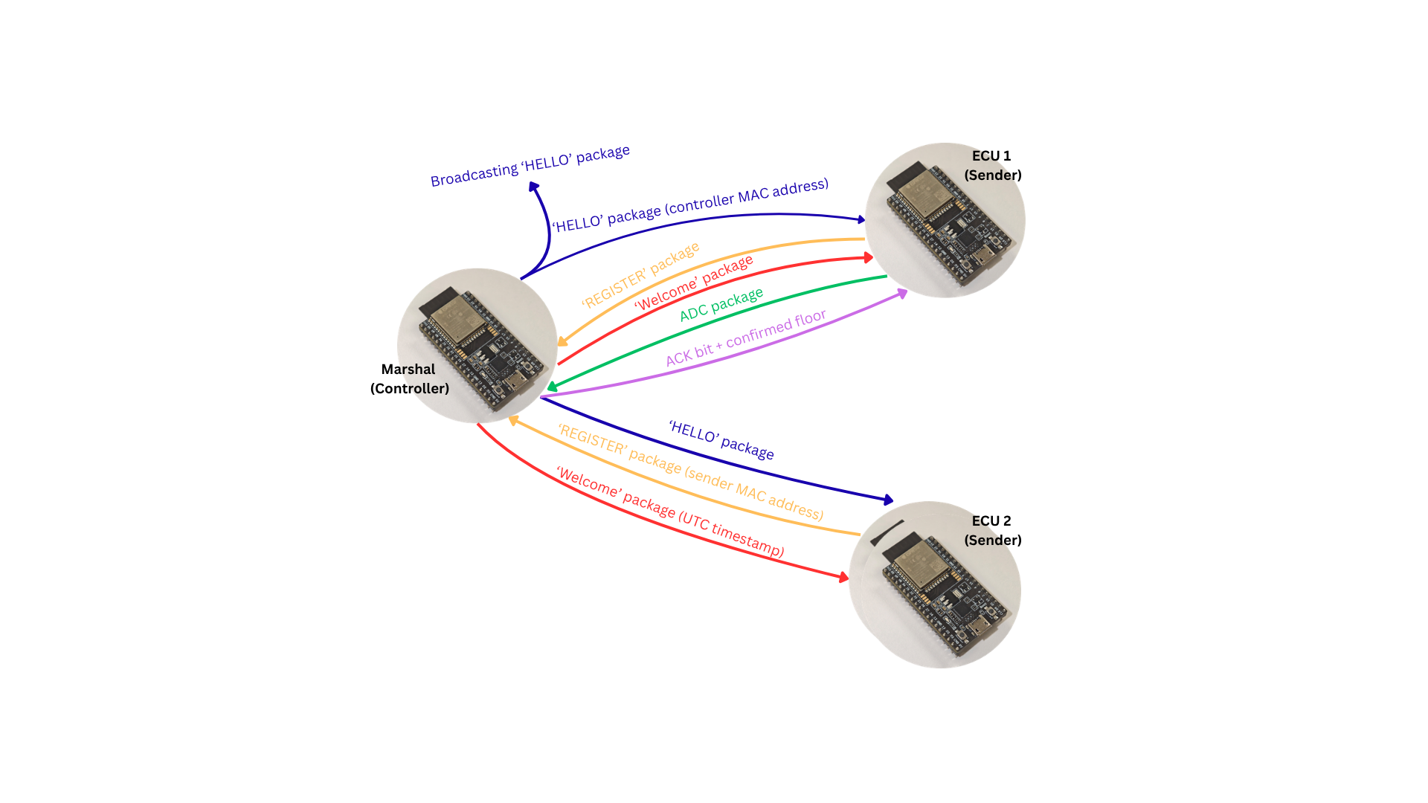
Figure 3: ESP-NOW message sequence diagram showing HELLO, REGISTER, WELCOME, DATA, ACK exchange

3.3.4 Power Saving Mode
The ECU enters low power mode when the voltage ADC reading is below 200 mV and the measured current stays within a small dead-band of roughly −0.55 A to +0.78 A (a 1120–1360 mV window on the current ADC channel) continuously for 30 seconds. This band targets the idle bias point of the hardware, where the op-amp produces a mid-rail offset (≈1219 mV, i.e. 0 A) when no current flows through the shunt. Any reading outside the band indicates real current in either direction, which resets the timer and keeps the system active.
Sleep uses WIFI_PS_MIN_MODEM while the CPU and all FreeRTOS tasks keep running, so ADC sampling and flash persistence continue uninterrupted. It is worth noting that this mode is designed around being associated to an access point, so without an AP association the actual radio saving is modest rather than a full power-down. Its real value for us is keeping the CPU and ADC active so the system can keep sampling and respond in real time, which the deeper built-in sleep modes do not allow.
A heartbeat packet is sent every 5000 ms to keep the controller's registry entry alive. On any out-of-band reading the ECU resumes normal transmission. Frames accumulated during sleep are discarded on wake-up, since data captured while the vehicle is inactive is not relevant to scoring. This was a deliberate trade-off: we give up some deeper power savings in exchange for the accuracy and control of keeping the ADC task running throughout.

3.3.5 Local Data Storage During Disconnections
To improve reliability during wireless connection interruptions, the transmitter employs a two-layer buffer architecture consisting of a large-capacity circular RAM buffer and a persistent SPIFFS flash storage layer. Newly acquired ADC frames are first inserted into the RAM transmission queue, allowing the system to maintain deterministic 100 Hz sampling and fast acknowledgment-based retransmissions without being blocked by slower flash operations. In parallel, each completed frame is continuously persisted to flash storage, providing a non-volatile backup of all unacknowledged data. This hybrid design combines the high-speed performance of RAM with the durability of flash memory, ensuring that sampled data can survive both temporary communication failures and unexpected device resets while also reducing excessive SPI flash access during normal operation.
In addition to volatile memory buffering, all sampled frames are continuously appended to a dedicated 2 MB SPIFFS partition on the ESP32 flash memory. The system also periodically stores the highest successfully acknowledged frame index in non-volatile storage. During startup, the transmitter scans the flash log sequentially and restores only frames newer than the last acknowledged index back into the RAM transmission queue. By reconstructing the queue in this manner, the system can resume transmission from the exact point of interruption after a reboot or unexpected power loss, without retransmitting already confirmed data.
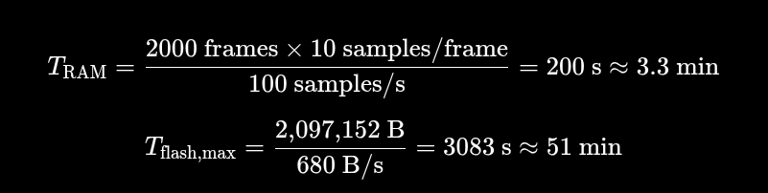
Figure 4. Calculated data retention capacity of the ESP32, showing the RAM retransmission window (T_{RAM} ≈3.3 min) and the maximum SPIFFS flash storage duration (T_{flash,max} ≈51 min) at full sampling resolution.
With the current 100 Hz ADC sampling and 10 samples per frame, the available flash capacity can retain approximately 50 minutes of continuous data. Since the project demonstration requirement only requires preserving full-resolution 100 Hz acquisition for at least 5 minutes during communication loss, the current implementation focuses on demonstrating reliable buffering and reboot-safe recovery rather than implementing more complex long-duration storage mechanisms.

3.3.6 Time Synchronisation (Team-Designed Feature)
Time synchronisation is the team-designed CompSys feature. Accurate timestamps are critical for the efficiency event, where energy consumption is calculated only within each team's specific race window defined by a start time and duration.
On boot, the ESP32 controller requests the current UTC time from the Python backend over UART, blocking until a valid timestamp response is received. This timestamp is embedded in every welcome message sent to sender ECUs during registration. When a sender receives a welcome message, it records both the UTC time and its own internal boot timer value at that moment, anchoring its monotonic clock to wall time. All subsequent frame timestamps are computed by adding the elapsed boot time to this anchor, avoiding the need for a real-time clock on the sender hardware.
Each frame captures the sender's internal boot timer value at the moment of sampling. When building a packet, the UTC timestamp is reconstructed by adding the elapsed boot time to the UTC anchor established at registration. This means frames buffered during a disconnection are correctly timestamped when they are eventually sent, because the boot timer kept running throughout. If a frame was captured before any registration completed, the timestamp cannot be reconstructed, and the serial reader falls back to the server's current time instead. This approach provides consistent timestamps across all ECUs without requiring a hardware real-time clock, at the cost of some clock drift during extended outages - an acceptable trade-off for the short, frequent re-registrations typical of race day.

3.3.7 Error Handling and Reliability
Peripheral initialisation calls use ESP_ERROR_CHECK() in every ECU, which aborts with a backtrace on any non-OK return value, ensuring misconfiguration is caught at startup rather than producing silent failures later. NVS corruption at boot triggers an automatic erase and reinitialisation. SPIFFS mount failures are logged and flash persistence is disabled gracefully, allowing the ECU to continue operating in-memory without crashing.
The task watchdog timer is configured with a 5-second timeout covering the idle tasks only. No application tasks subscribe to the watchdog explicitly, so the watchdog fires only if an idle task is permanently starved. This is a deliberate choice: the ADC and sender tasks use vTaskDelay() on every loop iteration, ensuring the idle task is never permanently blocked.

3.4 Software Design

3.4.1 System Architecture Overview
The software system follows a three-layer architecture: a React single-page application on the frontend, a FastAPI backend serving both REST and WebSocket endpoints, and a SQLite database accessed through a service layer. The backend is organised into routers, services, schemas, and models. Routers handle HTTP and WebSocket requests and delegate to service functions. Service functions contain all business logic and database access. Models define the ORM table structures. Alongside the FastAPI application, a standalone serial reader module runs as an async background task within the same process, using an OS thread and asyncio queue bridge to read energy frames from ESP32 Controller device over UART and feed them into the database via a shared service layer function. The serial reader module is also responsible for downward communication back to the ESP32 Controller device, sending commands such as power limit configurations over UART. This architecture maintains a clear separation of concerns across all layers, with each layer owning a distinct responsibility.
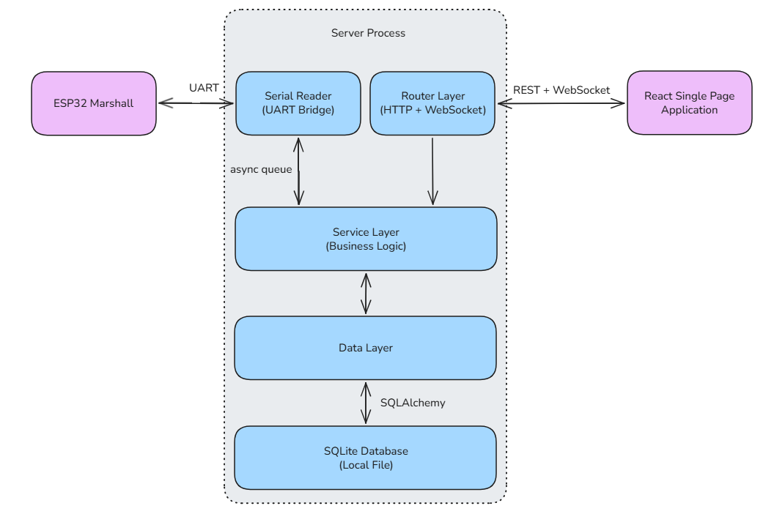
Figure 5: Software System Architecture

3.4.2 Backend Design
Overview: The backend follows a layered structure, separating concerns across four distinct components. The router layer handles all incoming HTTP and WebSocket requests, performing input validation before delegating it to the service layer. The service layer contains all business logic, including data persistence, violation detection, and real time broadcasting. The model/data layer defines the ORM table structures that map directly to the SQLite database. Additionally, there is an expected structure of all inbound data and outbound responses at every API boundary.
Technology stack: FastAPI was selected for its async-native architecture, which is required to handle concurrent WebSocket connections and real-time data ingestion from the UART serial reader background task simultaneously. We chose to go with UART serial communication instead of a wireless protocol such as HTTPS between our ESP32 controller and FastAPI backend process, due to EVolocity’s requirement for no internet connectivity. Pydantic integration enforces strict schema validation at every API boundary. SQLite was chosen because it requires no external server, allowing EVolocity to retain full data sovereignty, as all data remains on the operator's local machine.
Design patterns: Several design patterns and architectural principles are applied throughout the backend. The repository pattern isolates all database queries behind the service layer (business logic), separating request handling from data persistence logic. Dependency injection via FastAPI's Depends(get_db) provides each request with a scoped database session that is closed in a finally block regardless of exceptions, preventing session leaks. The observer pattern in service layer drives real-time notifications: a singleton ConnectionManager instance publishes new frames and violation events to all subscribed WebSocket clients without the data router knowing which clients are listening. A state machine in penalties.py manages violation lifecycle, with transitions from "started" to "escalated" to "ended" based on whether an open PowerViolationEvent record exists.
Concurrent WebSocket management: WebSocket connections are grouped by topic, for example team_3, or violations, and managed through a singleton connection manager. A frontend client subscribes to a topic and receives data whenever a new frame or violation event is published to that topic. Failed connections are detected and removed automatically, ensuring a single broken client cannot block delivery to others.
Serial bridge: The ESP32 Controller communicates with the backend over UART at 115,200 baud. Since blocking serial reads cannot run on the async event loop without stalling the server, the serial reader runs in a dedicated OS thread, passing frames into the async event loop via an internal queue. Power limit commands flow in the opposite direction through a separate queue, which the serial thread drains and writes back to the ESP32 Controller after every iteration of an inbound packet (energy frames) being processed.
Application startup: On startup the FastAPI application ensures the database schema is in place by creating any tables that do not already exist in the location configured in the environment variables, then conditionally starts the serial reader as a background task if a serial port is configured via environment variable, allowing the FastApi app to run without physical hardware connected.

3.4.3 Database Design
The database has seven tables. The key relationships are: an ECU belongs to a Team (nullable); a Team belongs to a Competition (nullable); a Competition has multiple CompetitionEvent rows, one per event type; and an EventParticipant links a Team to a CompetitionEvent with optional race start time and duration. EnergyFrame rows belong to both an ECU and a Team. PowerViolationEvent rows belong to an ECU.
Notable schema decisions include a composite unique constraint on (ecu_id, timestamp) in energy_frames to prevent duplicate frame insertion, a composite index on (ecu_id, timestamp) for efficient time-range queries, and cascade delete rules so that deleting a competition deletes its events and participant records but leaves teams intact via SET NULL.
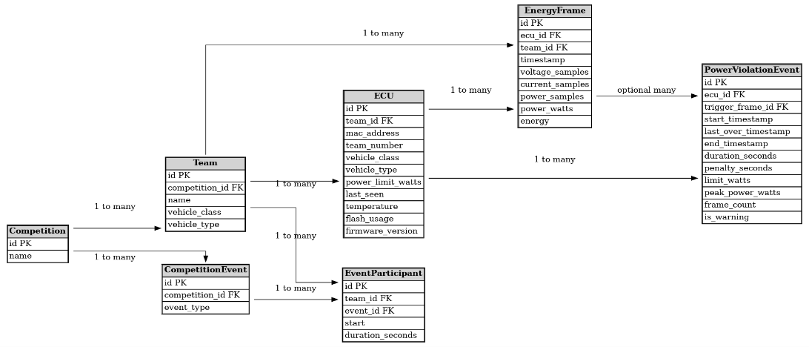
Figure 6: Entity-relationship diagram showing all seven tables and their foreign key relationships

3.4.4 Frontend Design
The frontend is a React 18 single-page application built with Vite. The component hierarchy has App.jsx at the root, managing global state including the selected competition, event, team, and ECU, as well as the violation log. Navigation between views is state-driven rather than route-based. The UI renders the Home Page (Figure D1), CompetitionsPage (Figure D2), LeaderboardPage (Figure D6), or Dashboard (Figure D3, Figure D4, Figure D5) depending on what is selected. The Navbar and Sidebar are always visible on competition and event pages. A full frontend design diagram can be seen in Figure D8.
WebSocket connections are managed through two custom hooks. useTeamWebSocket(teamId) manages the per-team channel, and useViolationsWebSocket(onEvent) manages the violations channel with an infinite reconnect loop using a mounted-ref guard to prevent reconnect attempts after component unmount. The underlying WebSocketClient class retries up to 5 times with a 3-second delay on close, but useViolationsWebSocket disables this cap and takes full ownership of the reconnect lifecycle.
The backend pushes energy frames to the team WebSocket channel, each containing arrays of 10 voltage, current, and power samples. The frontend expands each frame into 10 individual chart points with interpolated timestamps, appending them to a live buffer capped at 1000 points. The frontend calculates energy incrementally by integrating power over time as frames arrive.
When opening the site, the user is met with a home page (Figure D1), where they can add competitions and teams. From there they can view each competition (Figure D2) where they are able to add created teams to the competition and are able to also view the events. When clicking on one of these events, a leaderboard can be seen for energy efficiency as well as the multiteam graphs (Figure D6). Teams in the event can also be seen on the sidebar. When clicking on a team from this sidebar, they are taken to the teams dashboard where ECUs can be assigned, live and historical graphs for current, voltage and power can be seen, team information can be edited and power violations can be seen.

3.4.5 Feature 6: Multi-Team Comparison Dashboard (Team-Designed Feature)
Feature 6, the multi-team comparison dashboard, allows event administrators to monitor all competing vehicles simultaneously on shared voltage, current, and power charts (Figure D7). This directly addresses the supervision gap identified by the client in Week 8.
The multi-team comparison dashboard sits at the bottom of the leaderboard page and shows the shared graphs for selected teams in the event at the same time. Each team is assigned a colour, and users can toggle individual teams on or off using chips above the charts.
Under the hood, the component opens a separate WebSocket connection per team and buffers incoming data in memory rather than triggering a redraw on every message. It flushes to the charts at most four times per second to avoid the page becoming sluggish when many teams are streaming at once. Each team's trace is kept to its last 200 data points, and the x-axis shows relative time (e.g. "-5s", "-1m30s") rather than wall-clock timestamps so all teams line up visually regardless of when they started. Below the charts, a card for each selected team shows its ECU details and any recorded violations.

3.4.6 Power Limit Detection (Feature 4)
Power breach detection runs on both the ESP32 Sender and the backend, but for different purposes. The ESP32 detects breaches locally to trigger an immediate buzzer alert on the vehicle. The backend independently re-evaluates every ingested frame to create violation records, calculate penalty seconds, and push real-time notifications to the dashboard. The ESP32 transmits ADC readings; the backend calculates instantaneous power and compares it against the ECU's power threshold.
Violations with a duration with less than or equal to 1 second are classified as warnings and display as a yellow alert with no penalty. Beyond one second, these are displayed as penalties with a red box (Figure D5). This matches the EVolocity rulebook, which requires a sustained breach of over one second before a penalty is recorded.
On every state transition (started, escalated, ended), the PowerViolationEvent record is persisted to the database and broadcast to all /ws/violations subscribers. The frontend shows a warning toast on start, a persistent error toast with a red badge on escalation (breach exceeding 1 second), and appends the record to the NotificationPanel log on resolution.
The power limit is also forwarded to the physical ESP32 over UART whenever it is updated via the configuration endpoint. This provides a secondary on-device check at the firmware level, though the authoritative penalty record is always computed by the backend.

3.4.7 Development Workflow and CI
All changes to the codebase were delivered through pull requests to main. Branches were named descriptively and commits followed conventional commit message conventions (feat:, fix:, test:, etc.). Each pull request required at least one peer review before merging.
Five automated CI jobs run on every pull request via GitHub Actions: Markdown linting, broken link checking (with URL caching), backend unit tests (Python 3.12, flake8 lint, then pytest against an in-memory SQLite database), frontend ESLint and Vite production build verification, and frontend unit tests via Vitest. Backend tests use FastAPI's ASGI test client with httpx.AsyncClient, meaning no external server or database is required to run the full test suite.

3.4.8 Software Bill of Materials
All dependencies are free for commercial use. This abides by the client’s requirement for a $0 licence budget. The full SBoM is reproduced in Table 2 below.
Package | Version | Licence
fastapi | ≥0.100 | MIT
uvicorn[standard] | ≥0.20 | BSD-3-Clause
sqlalchemy | ≥2.0 | MIT
prop-types | 15.8.1 | MIT
pydantic | ≥2.0 | MIT
pydantic-settings | ≥2.0 | MIT
python-dotenv | ≥1.0 | BSD-3-Clause
python-multipart | ≥0.0.6 | Apache 2.0
pyserial | ≥3.5 | BSD-3-Clause
pytest | 9.0.3 | MIT
httpx | ≥0.24 | BSD-3-Clause
react | ^18.0.0 | MIT
recharts | ^2.0.0 | MIT
react-toastify | ^11.1.0 | MIT
vite | ^5.0.0 | MIT
Table 2: Software Bill of Materials.
All licences permit free commercial use with no copyleft restrictions.

3.4.9 Software Future Design Plans
Two commits were made to the software repository after the 11:59 AM code submission deadline on demo day.
Scoring logic extension: The leaderboard scoring function was refactored to support a live open-window mode. Previously, participants without a fixed duration were scored against an arbitrary 30-second window of recent frames, which was not anchored to their actual race start and could include irrelevant data. The updated logic introduces three cases: participants with both a start time and duration are scored against a fixed window capped at 30 seconds, giving a stable rank; participants with a start time but no duration are scored against a live window stretching from their start to the current time, capped at one hour, so their rank updates as new frames arrive without relying on an arbitrary window; and participants with no start time are marked pending immediately. This means administrators can begin tracking a team's energy usage from the moment their race starts, even before a duration is known, while keeping comparisons between teams fair by never scoring a team against an undefined window.
Frontend cleanup: eslint-plugin-react-hooks was added and its recommended rules formally enabled. An existing suppression comment in AllTeamsOverview.jsx was removed as the dependency array was already correct. The Navbar system health display and Sidebar violatingEcuIds prop were also removed. These changes were purely for code quality and cleanup and do not affect any functionality.

3.5 Solution Cost and BOM
Quantity per unit | Cost per 100 components | Designators | Description | Value | Package | Supplier | Supplier Part # | Manufacturer | Manufacturer Part #
4 | $1.90 (0.019) | R29, R30, R24B, R25B | Resistor,SMD | 0Ω ±1% | 0805 | DigiKey | P0.0ACT-ND | Panasonic | ERJ-6GEY0R00V
1 | $3.13 ($0.0313) | R28 | Resistor,SMD | 330Ω ±1% | 0805 | DigiKey | P330CCT-ND | Panasonic | ERJ-6ENF3300V
9 | $3.13 | R6, R27, R26, R16, R9, R11, R33, R23, R22 | Resistor,SMD | 1kΩ ±1% | 0805 | DigiKey | P1.00KCCT-ND | Panasonic | ERJ-6ENF1001V
3 | $3.13 | R3, R4, R5 | Resistor,SMD | 2.2kΩ ±1% | 0805 | DigiKey | P2.20KCCT-ND | Panasonic | ERJ-6ENF2201V
3 | $3.13 | R8, R12, R13 | Resistor,SMD | 10kΩ ±1% | 0805 | DigiKey | P10.0KCCT-ND | Panasonic | ERJ-6ENF1002V
1 | $3.13 | R19 | Resistor,SMD | 12kΩ ±1% | 0805 | DigiKey | P12.0KCCT-ND | Panasonic | ERJ-6ENF1202V
1 | $3.13 | R17 | Resistor,SMD | 33kΩ ±1% | 0805 | DigiKey | P33.0KCCT-ND | Panasonic | ERJ-6ENF3302V
1 | $3.13 | R18 | Resistor,SMD | 100kΩ ±1% | 0805 | DigiKey | P100KCCT-ND | Panasonic | ERJ-6ENF1003V
1 | $3.13 | R7B | Resistor,SMD | 22kΩ ±1% | 0805 | DigiKey | P22.0KCCT-ND | Panasonic | ERJ-6ENF2202V
1 | $3.13 | R7A | Resistor,SMD | 220kΩ ±1% | 0805 | DigiKey | P220KCCT-ND | Panasonic | ERJ-6ENF2203V
2 | $3.13 | R15B, R14B | Resistor,SMD | 6.8kΩ ±1% | 0805 | DigiKey | P6.80KCCT-ND | Panasonic | ERJ-6ENF6801V
2 | $3.13 | R15A, R14A | Resistor,SMD | 68kΩ ±1% | 0805 | DigiKey | P68.0KCCT-ND | Panasonic | ERJ-6ENF6802V
2 | $3.13 | R24A. R25A | Resistor,SMD | 82kΩ ±1% | 0805 | DigiKey | P82.0KCCT-ND | Panasonic | ERJ-6ENF8202V
3 | $20.29 (0.2029) | R1, R2A, R3A | Resistor,SMD | 0.001Ω ±1% | 2512 | DigiKey | D1MPAB2512RR001FA-T4 | Thin Film Technologu Corp | D1MPAB2512RR001FA-T4
1 | $11.42 ($0.1142) | D4, D5 | Diode,SMD | 1N4148W-7-F | SOD-123 | DigiKey | 1N4148W-FDICT-ND | Diodes Inc. | 1N4148W-7-F
2 | $27.59 (0.2759) | D1, D2 | LED,SMD | Green | 0805 | DigiKey | 732-4983-1-ND | Würth Elektronik | 150080GS75000
1 | $27.59 (0.2759) | D3 | LED,SMD | Red | 0805 | DigiKey | 732-4985-1-ND | Würth Elektronik | 150080SS75000
1 | $109.89 ($1.0989) | U3 | Voltage Regulator,TH | L7805CV | TO-220 | DigiKey | 497-1443-5-ND | STMicroelectronics | L7805CV
1 | $167.97  110 units ($1.57) | U1 | Op-Amp,SMD | LM324AM/NOPB | SOIC-14 | DigiKey | LM324AMNS/NOPB-ND | TI | LM324AM/NOPB
0 | $19.49  ($0.1949) | U4 | Op-Amp,SMD | LM358BIDR | SOIC-8 | DigiKey | 296-LM358BIDRCT-ND | TI | LM358BIDR
1 | $15.84  (0.1584) | Q1, Q2 | Transistor,SMD | BC817-40W-7-F | SOT-23 | DigiKey | BC817-40WDICT-ND | Diodes Inc. | BC817-40W-7
1 | $113.89  ($1.1389) |  | Buzzer Magnetic,SMD | OWMB-858540SA-40-15 | SMD | DigiKey | 3949-OWMB-858540SA-40-15CT-ND | KEPO | OWMB-858540SA-40-15
1 | $1827.00 ($18.27) |  | ESP32 DevKitC Development Board | ESP32-WROOM-32E | Module / 38-pin DevKitC | DigiKey | 1965-ESP32-DEVKITC-32E-ND | Espressif Systems | ESP32-DEVKITC-32E
1 | $135.87  (x100 PCBs) |  |  |  |  | PCBWAY
Total Cost per unit  (Before GST) |  | $26.067 |  |  | Total Cost per unit with GST |  | $29.97
Table 3: Bill of Materials and Component Cost Breakdown

4.0 Business Value of the Solution

4.1 Value to EVolocity and Event Administrators
The most direct value delivered by this solution is the elimination of manual USB-C data retrieval after each race. Under the current system, race officials cannot finalise results until they physically plug into every competing vehicle, a process that gets longer as participation grows. The new system transmits energy data wirelessly and continuously throughout the race, meaning results are available on the dashboard as soon as the race ends. This reduces parc ferme time, speeds up the overall event schedule, and reduces the risk of data loss from a missed connection.
Beyond data collection, the software dashboard provides real-time visibility across all competing vehicles simultaneously. Feature 6, the multi-team comparison view, directly addresses a supervision gap identified by Keith Anderson during the Week 8 client meeting. Previously, administrators had no way to watch multiple vehicles at once and had to navigate between individual team pages to monitor readings. The new view allows all active ECU telemetry to be displayed side by side, making it far easier to identify unusual readings or power limit breaches across the field during live racing. This is particularly important during the endurance and efficiency event, where the ability to spot a power violation in real time rather than reviewing logs after the fact meaningfully supports fair and efficient race administration.
The power limit notification feature (Feature 4) complements this by automatically alerting administrators when any vehicle exceeds its class power threshold. Combined with the multi-team view, event administrators now have the tools to supervise an entire race from a single screen without specialised technical knowledge.

4.2 Value to Competing Teams and Students
Competing teams benefit from fairer scoring. Bidirectional current sensing means energy recovered through regenerative braking is now correctly subtracted from a team's total consumption. Previously, teams using this technology might’ve been penalised relative to those that did not because the unidirectional ECU treated recovered energy as zero. This change ensures the efficiency event rewards efficient engineering, which is central to EVolocity's educational mission.
The efficiency leaderboard (Feature 5) makes standings visible in real time throughout the race, which creates an engaging experience for teams, pit crews, and spectators. As Keith Anderson noted during the client meeting, EVolocity has previously considered allowing teams and parents to follow their vehicle's data on their own devices. The current solution does not yet implement a public-facing portal, but the architecture is designed to support this as a future extension without changes to the hardware.
Historical race data stored per team (Feature 2) also means that after a race day, EVolocity and competing schools can review a team's energy usage across events. This kind of longitudinal data has value both for coaching and for EVolocity's ongoing programme evaluation.

4.3 Unique Value and Points of Difference
The multi-team comparison view (Feature 6) is the most significant point of difference in this solution relative to the minimum requirements. It builds entirely on data already being transmitted by the ESP32 ECUs, so there is no additional hardware cost or infrastructure requirement. The feature was designed in direct response to the operational challenge described by the client and provides value that goes beyond what a basic dashboard delivers.
The time synchronisation feature implemented by the computer systems team provides another meaningful improvement over a naive wireless implementation. Each ECU synchronises its internal clock with the server when the controller is connected. This ensures that energy accumulation totals calculated for the efficiency event use consistent time references across all vehicles, even those that experienced a disconnection earlier in the day. This directly addresses the scoring challenge described by Keith Anderson in the Week 8 client meeting, where he noted that clock drift over a 10 to 15 minute outage could affect energy tallies and result in unfair scoring.
Together, these two team-designed features provide real value to EVolocity that extends beyond the specified minimum requirements.

4.4 Cost and Bill of Materials
The estimated cost per ECU unit is approximately $29.97 NZD, covering the custom PCB components and the ESP32 DevKitC development board. All software infrastructure runs at zero ongoing cost, consistent with EVolocity's requirement for a $0 software budget. The system is self-hosted on a Windows laptop provided by the event operator, with no cloud services, paid APIs, or external subscriptions required. A full itemised Bill of Materials is provided in Section 3.5.

4.5 Sustainability
Engineering for sustainability requires thinking beyond immediate functionality to consider the full lifecycle of a product: its energy consumption during use, its hardware footprint, its repairability, and the broader purpose it serves. EVolocity's founding mission is to connect young New Zealanders with electric vehicle technology at an age when career pathways are still forming. New Zealand already generates over 80–85% of its electricity from renewable sources, meaning that every student who leaves EVolocity with an understanding of electric drivetrains and efficient energy use is better equipped to contribute to the country's electrification goals. The ECU system built by Team 6 directly supports EVolocity's ability to deliver that mission at scale.
At the level of the hardware itself, the solution is designed with efficiency in mind. The ESP32 implements a power saving mode that reduces current draw significantly when no meaningful race activity is detected, extending the effective battery life of each ECU across a full race day. This was a direct requirement from EVolocity and reflects the broader principle of minimising energy consumption in embedded systems.
The custom PCB uses standard FR4 substrate and is manufactured through a conventional process. While the prototype was not designed with a specific end-of-life recycling plan, the use of a single compact board per ECU minimises material use relative to a solution using off-the-shelf breakout boards, and the low component count means the design is straightforward to repair or update in future iterations.
From a broader SDG perspective, the solution contributes to four of the United Nations Sustainable Development Goals. It most directly supports SDG 4 (Quality Education) by making the EVolocity programme easier to run, faster to score, and fairer to compete in, which strengthens EVolocity's capacity to deliver hands-on STEM education to more schools across New Zealand. It supports SDG 7 (Affordable and Clean Energy) and SDG 13 (Climate Action) by promoting electric vehicle technology and rewarding regenerative energy recovery among young engineers. The efficiency event, now scored accurately for all drivetrain configurations, gives students a direct and competitive incentive to understand why energy efficiency matters. It also supports SDG 9 (Industry, Innovation and Infrastructure) by contributing to the IoT and telemetry infrastructure that underpins modern EV systems, and by demonstrating that low-cost, locally built monitoring hardware can meet production-grade accuracy requirements.

4.6 Data Sovereignty and Privacy Regulatory Compliance

Data sovereignty in Aotearoa New Zealand is defined by two distinct pillars: national data sovereignty, which holds that data about New Zealanders should remain under New Zealand law and not be subject to foreign jurisdictions; and Māori Data Sovereignty (MDSov), which recognises that Māori data is a taonga and that Māori communities have inherent rights to control data that relates to their people, resources, and outcomes. Both pillars are directly relevant to this project and shaped concrete design decisions.

A significant risk with many modern software systems is reliance on global cloud infrastructure. Even cloud providers with data centres located in New Zealand may be subject to the US CLOUD Act, which permits US authorities to compel access to data held by US-owned companies regardless of where that data physically resides. For a system that will collect data about school-aged students and their teams, data that falls squarely within the spirit of MDSov, this risk is not theoretical. The architectural response to this risk is technical and deliberate: all data collected by the system is stored in an SQLite database on the event operator's local Windows laptop. The backend makes no outbound connections to any cloud service, external API, or third-party server. All communication between the ECU hardware and the software runs over a UART serial link to a locally connected ESP32, then through a local FastAPI process, with the browser dashboard served to the operator's own machine over localhost. The data never leaves the venue. This means it cannot be subject to a foreign jurisdiction, cannot be compelled by an overseas authority, and remains entirely under EVolocity's direct control.

This architecture is consistent with the Privacy Act 2020 Information Privacy Principles (IPPs) in several specific ways. Under IPP 1 to 4 (purpose and minimisation), the system collects only team numbers, vehicle class configurations, and energy measurement readings. No names, school identifiers, or other personally identifiable information about individual students are collected or stored, reflecting the principle of collecting only what is necessary for a lawful purpose. Under IPP 5 (storage security), the local-only architecture limits the attack surface to the operator's machine on the event network. Because the dashboard is accessed from the same machine running the backend, and the ESP32 communicates via a direct UART connection rather than over a network, external access to the database during competition is not possible under normal operating conditions. Under IPP 10 and 11 (use and disclosure), the data is used solely for race scoring and administration and is not shared with third parties or used for any secondary purpose, so no additional consent obligations arise. The new IPP 3A principle, which came into force on 1 May 2026 and requires agencies to notify individuals when their information is collected from a third party, does not apply here because all data originates directly from the ECU on each vehicle with no third-party data sources involved.

Regarding Māori Data Sovereignty specifically, EVolocity serves Māori and Pasifika rangatahi who are underrepresented in engineering and technology fields. Competition data about their teams and vehicles, including scoring outcomes, energy profiles, and violation records, constitutes data about Māori participants and their engineering work. Under the Te Mana Raraunga framework, this data should be subject to principles of Rangatiratanga (authority: Māori communities having jurisdiction over their own data), Kaitiakitanga (guardianship: protecting that data for future participants), and Manaakitanga (upholding the dignity of the people the data represents). The local-first, EVolocity-controlled architecture directly satisfies these principles: EVolocity retains full authority over the data, there is no pathway for it to leave the programme's governance, and the accuracy of the data, ensured by calibrated bidirectional sensing validated to within ±2.5%, means that the scores derived from it faithfully reflect each team's engineering work.

Should EVolocity choose to make race data accessible to teams or the public in a future iteration, IPP 10 and 11 would require careful consideration of whether the new use falls within the original collection purpose. The read-only public portal described in Section 5.2 would need to be designed with this obligation in mind, and EVolocity would need to establish a clear privacy statement for participants prior to implementing it.

4.7 Radio Regulatory Compliance

The ESP32-WROOM-32 module used in this solution transmits over the 2.4 GHz band (2400–2483.5 MHz) using the ESP-NOW protocol, which operates at the 802.11 b/g/n physical layer without requiring a full Wi-Fi association or IP stack. All radio activity in this solution, covering both the ECU-to-controller ESP-NOW link and the controller's own radio, operates entirely on this band.

Operation on the 2.4 GHz band for short-range data devices in New Zealand is permitted under the General User Radio Licence (GURL) for Short Range Devices, administered by Radio Spectrum Management (RSM) under the Radiocommunications Act 1989. No individual licence is required for devices operating within the GURL conditions, which specify permitted frequency ranges and maximum power levels. The ESP32-WROOM-32 module holds FCC certification issued by the US Federal Communications Commission, and RSM recognises major international certifications including FCC for the purposes of GURL compliance. The module operates within the GURL power limits on the 2.4 GHz band, confirming that deployment at EVolocity competition venues requires no additional regulatory approval beyond what is already satisfied by the hardware.

Because Team 6 sourced the ESP32 DevKitC from an overseas distributor, the team is technically the importer of record for the devices. For a university prototype used in a competition setting, personal and prototyping use is generally acceptable provided the device operates within GURL conditions, which it does. However, if EVolocity were to scale this solution into a product distributed to schools across New Zealand, the final product would need to carry an R-NZ or RCM compliance label and EVolocity would need to hold a Licence to Supply from RSM. This is a standard process for commercial IoT products in New Zealand and would not require changes to the circuit or firmware design, since the ESP32-WROOM-32 module already holds the international certifications that RSM recognises. This pathway is described further in Section 5.2.

4.8 Te Tiriti o Waitangi

Te Tiriti o Waitangi establishes three principles that are directly relevant to engineering work undertaken in Aotearoa New Zealand: Partnership (Article I), Participation (Article II), and Protection (Article III). These are not merely background context; they have shaped specific design decisions in this project.

Partnership: Partnership under Te Tiriti means that decisions affecting communities are made collaboratively, with no single group having unilateral authority over the other. EVolocity operates through exactly this kind of multi-stakeholder relationship, bringing together schools, the University of Auckland as a long-term sponsor and technical partner, and the broader engineering community. Team 6's engagement with EVolocity was conducted in the spirit of this principle: the design was shaped by direct dialogue with Keith Anderson and the EVolocity team, including a kanohi ki te kanohi (face to face) client meeting in Week 8 where real race-day workflows and scoring challenges were discussed in person. The technical decisions that followed, including the multi-team dashboard, the time synchronisation feature, and the bidirectional current sensing, were all direct responses to what that conversation revealed. This is what partnership looks like in an engineering context: a relationship built on mutual understanding rather than assumptions about what the client needs.

Participation: Article II of Te Tiriti guarantees the full rights of chieftainship, tino rangatiratanga, over one's taonga. In the context of a STEM competition, the ability of all teams to participate on equal terms and have their engineering work assessed accurately is a form of tino rangatiratanga in practice. EVolocity actively recruits Māori and Pasifika rangatahi who are underrepresented in engineering pathways. These students invest a year of effort designing and building their vehicles, and their scores depend on the accuracy of the ECU. The previous unidirectional current measurement system created a structural disadvantage: teams whose vehicles used regenerative braking had their energy recovery ignored or corrected by hand. This is the kind of inequity that the participation principle exists to address. The bidirectional current sensing implemented in this solution corrects it directly; all energy recovered through regenerative braking is now measured accurately, and every team's score reflects what their vehicle actually did. Accurate, fair scoring is a prerequisite for manaakitanga, upholding the dignity of participants and ensuring their engineering work is valued on its true merits.

Protection: Article III of Te Tiriti guarantees the full rights and protections of the Crown, and the protection principle extends this to ensuring that communities are protected from harm by systems that affect them. In the data context, protection requires that information about participants is handled in a way that preserves their interests. As discussed in Section 4.6, competition data about student teams, including Māori and Pasifika rangatahi, falls within the spirit of Māori Data Sovereignty. The local-first architecture, in which all data is stored on EVolocity's own hardware with no cloud dependency and no pathway to a foreign jurisdiction, is a design choice that gives practical effect to the protection principle. EVolocity acts as kaitiaki, guardian, of the data collected about its participants, and the system is built so that this guardianship is technically enforced rather than left to policy alone. The data remains under the control of the organisation that participants and their whānau have a relationship with, and it cannot be accessed, shared, or compelled by any external party without EVolocity's knowledge and consent.

5.0 Conclusions

5.1 Summary of Achievements Against Client Requirements
Table 4 below maps every requirement specified by EVolocity against what was delivered in the final prototype.
Requirement | Status | Detail
Wireless data collection replacing USB-C retrieval | Delivered | ESP-NOW for ECU-to-controller, UART for controller-to-server
Self-restoring, disconnect-tolerant connection | Delivered | ECU re-registers on next HELLO broadcast; full backlog transmitted automatically on reconnection
Support multiple ECUs simultaneously | Delivered | Controller registry supports up to 20 nodes with independent per-ECU ACK tracking
Minimum 128 kB/s throughput | Delivered | ESP-NOW 2.0 supports up to 1 Mbps at the physical layer
Compliant with NZ radio regulations | Delivered | Operates within the GURL for Short Range Devices on the 2.4 GHz band
Measure voltage across 18 to 60 V range | Delivered | Validated within 2.5% of calibrated bench equipment at final demonstration
Measure bidirectional current up to 100 A | Delivered | Low-side shunt with offset amplifier; 0 A centred at ADC midpoint of 1.225 V
Unit-to-unit variation within 0.5% | Delivered | Confirmed across both prototype PCBs at Milestone 2 and final demonstration
Accuracy within 2.5% of calibrated equipment | Delivered | Confirmed across both prototype PCBs at final demonstration
Sample current and voltage at minimum 100 Hz | Delivered | FreeRTOS esp_timer-gated loop enforces 10 ms sample period in adc task
Store at least 5 minutes of data locally | Delivered | 2000-frame circular buffer plus SPIFFS persistence across reboots
Transmit buffered data on reconnection | Delivered | sender_task drains unacknowledged frames automatically at maximum rate
Data frequency at minimum 0.2 Hz | Delivered | Energy frames transmitted and stored above this rate under normal operation
Detect and report power limit violations | Delivered | Backend penalties.py implements full violation lifecycle with persistent records
Configure ECUs through software UI | Delivered | Vehicle class, vehicle type, team number, and power limit configurable per ECU
Graph and store energy frame data | Delivered | Live Recharts graphs and paginated historical view per team and ECU
Show list of connected and disconnected ECUs | Delivered | Sidebar ECU list with status, updated every 10 seconds via REST polling
Create and manage teams | Delivered | Feature 1: custom team name, vehicle class, vehicle type, ECU assignment
Access historical race data per team | Delivered | Feature 2: historical frames accessible via team view, filterable by event window
Create and manage competitions | Delivered | Feature 3: competitions with all three standard event types, team enrolment
Power limit breach notifications | Delivered | Feature 4: toast alerts on breach start, persistent error on escalation past 1 second
Efficiency leaderboard | Delivered | Feature 5: ranked by total energy use, lower energy ranked higher
Simultaneous multi-team monitoring | Delivered | Feature 6: all live ECU telemetry displayed side by side with 4 Hz render batching
Time synchronisation across ECUs | Delivered | Team-designed CompSys feature; UTC timestamp anchored on every WELCOME received
$0 software infrastructure budget | Delivered | Fully self-hosted on a Windows laptop, no external services or paid dependencies
All software dependencies free for commercial use | Delivered | Full SBoM in Section 3.4.8; all licences verified as MIT, BSD, or Apache 2.0
Table 4: Client Requirements Delivery Status

5.2 Planned Future Work
OTA Firmware Updates: The server-side OTA infrastructure is implemented: the firmware router validates uploaded .bin files against the ESP32 magic byte, stores them with a SHA-256 checksum, serves them for download, and accepts progress callbacks from the device, with an in-memory tracker recording the job lifecycle (pending → downloading → flashing → success/failed). What we didn't finish is the ESP32-side receive-and-flash logic. This is more involved than a simple esp_https_ota call: the sender currently has only a single factory partition (so it would need repartitioning into an OTA layout), and because our ECUs run ESP-NOW with no Wi-Fi association or IP stack, they can't reach the server's HTTP download endpoint directly. The firmware would instead need to be streamed in chunks over the existing serial/ESP-NOW link. This is the highest-priority item for the next sprint.
Adaptive Storage-Aware Sampling: Instead of maintaining a constant sampling frequency indefinitely, the ECU could dynamically reduce the ADC sampling rate as remaining flash capacity decreases. For example, the system may retain 100 Hz acquisition while sufficient storage remains, then gradually reduce the sampling frequency as the flash partition approaches capacity. This would trade temporal resolution for significantly extended retention duration, allowing more than 4.5 hours of continuous local buffering within the same fixed flash size while still preserving high-resolution measurements during the initial critical disconnection period.
Wireless Range Beyond Lab Distance: The prototype was tested across approximately 10 to 15 metres during Milestone 2 and the final demonstration, confirming reliable operation at lab scale. Formal range validation at the 100+ metres specified by EVolocity for outdoor race day use was not performed. ESP-NOW on the 2.4 GHz band typically achieves 200 to 400 metres line-of-sight at the power levels permitted under the GURL. A higher-gain or directional antenna mounted on the controller unit would extend this further. Range testing over an outdoor course representative of a real race track should be completed before race day deployment.
Public-Facing Live Data Portal: The current system is designed for internal use by event administrators only. A portal allowing competing teams, pit crews, and spectators to follow live data on their own devices was raised by Keith Anderson during the Week 8 client meeting as a longer-term aspiration. The existing backend WebSocket architecture could support this through a read-only public channel and a lightweight authentication layer, but it was outside the scope of this prototype and was not implemented.
Hardware Real-Time Clock: The ESP32 has no battery-backed, high-accuracy RTC, so timekeeping currently relies on the server timestamp carried in each WELCOME packet, which is adequate under normal race-day conditions. For production, a hardware RTC such as the DS3231 (I2C, ±2 ppm) would let ECUs hold accurate time through extended disconnections with negligible drift. The DS3231 is low-cost and well-documented; integration would need a minor PCB revision plus a small firmware change to initialise the RTC, set it from the backend time, and use it as the timestamp anchor.
Commercial Regulatory Compliance (R-NZ Labelling): The prototype operates legally under the GURL for personal prototyping use. If EVolocity were to distribute the device to schools across New Zealand, the final product would need to carry an R-NZ or RCM compliance label and EVolocity would need to hold a Licence to Supply from Radio Spectrum Management. This requires formal certification testing but is a standard process for commercial IoT devices in New Zealand and would not require any changes to the circuit design, as the ESP32 module already holds FCC certification which RSM recognises.
Summary: For EVolocity to move from this prototype to a production deployment, the recommended steps in priority order are: complete the ESP32-side firmware receive-and-flash logic to enable remote firmware updates without physical access to each device, noting that the server-side OTA infrastructure is already implemented; validate wireless range on a representative outdoor course, as the prototype was tested only at laboratory distances of 10-15 metres and ESP-NOW on the 2.4 GHz band is expected to achieve 200-400 metres line-of-sight under GURL-permitted power levels; conduct a formal race day simulation with multiple ECUs, real vehicle loads, and an event administrator operating the software across a full event day; add a hardware RTC module such as the DS3231 to the PCB to provide accurate timekeeping through extended disconnections without relying on server-issued timestamps; implement a public-facing live data portal to allow competing teams, pit crews, and spectators to follow vehicle telemetry on their own devices, as raised by Keith Anderson during the Week 8 client meeting, noting that the existing WebSocket architecture already supports this through a read-only public channel and a lightweight authentication layer, requiring no hardware changes; and engage with Radio Spectrum Management to begin the Licence to Supply process if distribution to schools is planned, as the current prototype operates legally under the GURL for personal and prototyping use but a commercially distributed product would require R-NZ or RCM labelling. The software architecture requires no significant changes to support a full race day and is ready for deployment in its current form.

Appendices
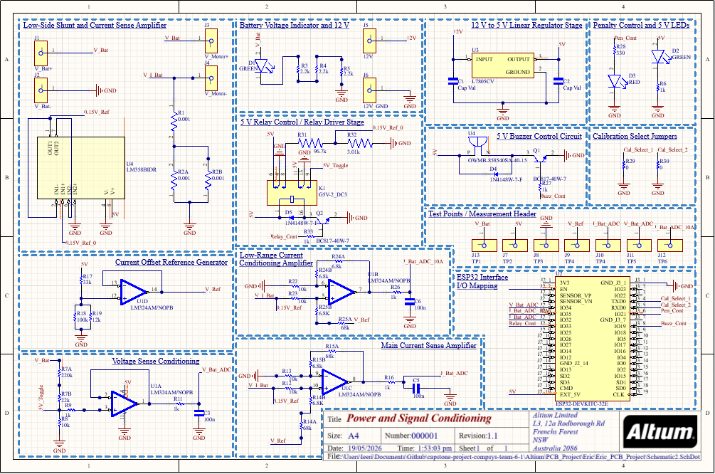
Figure A1: Full circuit schematic for the Power and Signal Conditioning PCB (Altium Designer, Revision 1.1, 19/05/2026). Encompasses 14 functional sub-circuits including voltage and current sensing amplifiers, the ESP32 interface, relay driver, buzzer, LED indicators, and calibration jumpers.

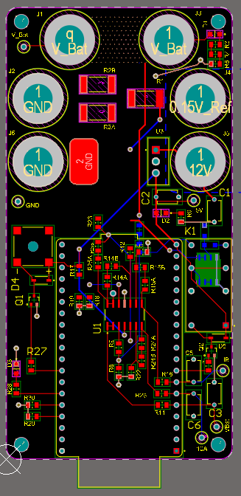
Figure A2: PCB top-layer layout exported from Altium Designer. The board uses FR4 substrate in a compact portrait form factor, with power connectors at the perimeter and the ESP32 header centred to minimise ADC signal trace lengths.

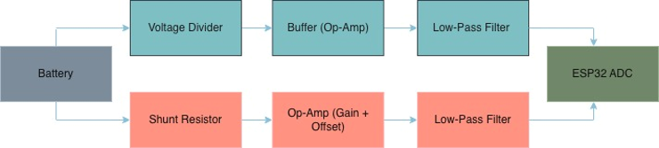
Figure A3: Signal conditioning chain block diagram showing the two independent measurement paths from battery terminals to the ESP32 ADC. The voltage path (top) passes through a resistive divider, unity-gain buffer, and low-pass filter. The current path (bottom) passes through a shunt resistor, two-stage op-amp amplifier with mid-rail offset, and low-pass filter.

Load (A) | Board 1 Calc (A) | Board 1 Error (%) | Board 2 Calc (A) | Board 2 Error (%)
3.00 | 3.009 | +0.30 | 2.988 | −0.41
2.80 | 2.813 | +0.48 | 2.793 | −0.26
2.60 | 2.618 | +0.68 | 2.592 | −0.30
2.40 | 2.389 | −0.48 | 2.403 | +0.12
2.20 | 2.204 | +0.19 | 2.202 | +0.10
2.00 | 2.003 | +0.14 | 2.007 | +0.37
1.80 | 1.790 | −0.53 | 1.812 | +0.69
1.60 | 1.600 | +0.03 | 1.617 | +1.09
1.40 | 1.399 | −0.06 | 1.422 | +1.60
1.20 | 1.209 | +0.76 | 1.311 | +0.85
1.00 | 1.019 | +1.90 | 1.261 | +0.87
Figure A4: PCB1 current measurement validation results for the Red and Green boards. Measured current (calibrated ammeter reference) is compared against ADC-derived calculated values across the 1–3 A operating range. Maximum error is under ±2% across the full tested range, confirming both boards meet the ±2.5% accuracy specification.

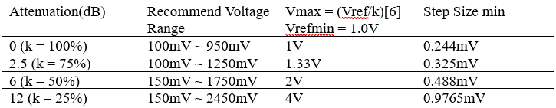
Figure B1: ESP32 ADC attenuation levels and corresponding recommended voltage ranges and minimum step sizes. At 12 dB attenuation the effective input range is 150 mV–2450 mV with a 0.9765 mV step size. Source: Espressif ESP32 Technical Reference Manual.
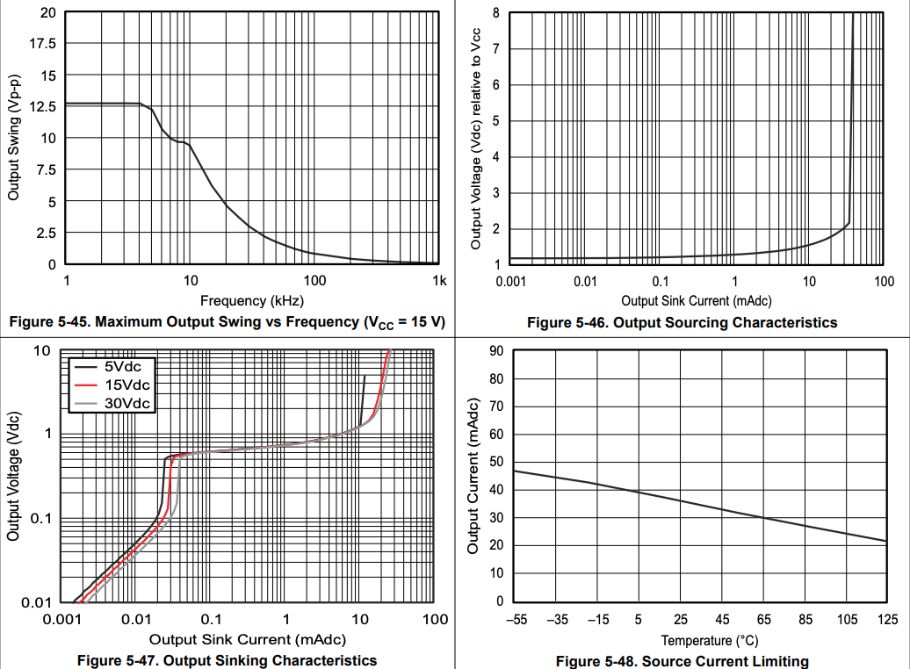
Figure B2: LM324 output current limitations. Output swing degrades above ~10 kHz; sourcing and sinking characteristics determine safe output swing relative to supply voltage. Used to confirm the op-amp can drive the RC filter and ADC input without droop. Source: Texas Instruments LM324 Datasheet.

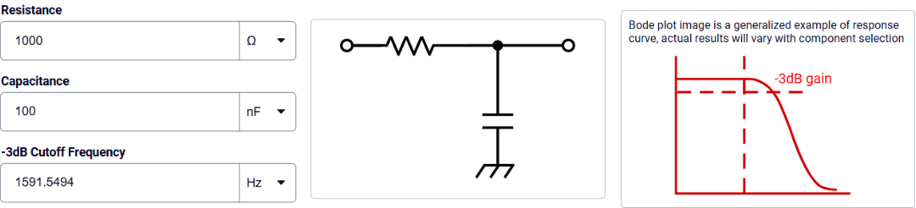
Figure B3: First-order RC low-pass filter design calculator confirming R = 1 kΩ, C = 100 nF yields a −3 dB cutoff frequency of f_c = 1591.5 Hz. The series-R shunt-C topology (centre diagram) is used on both the voltage and current signal paths to attenuate switching noise while preserving near-DC energy measurement signals.

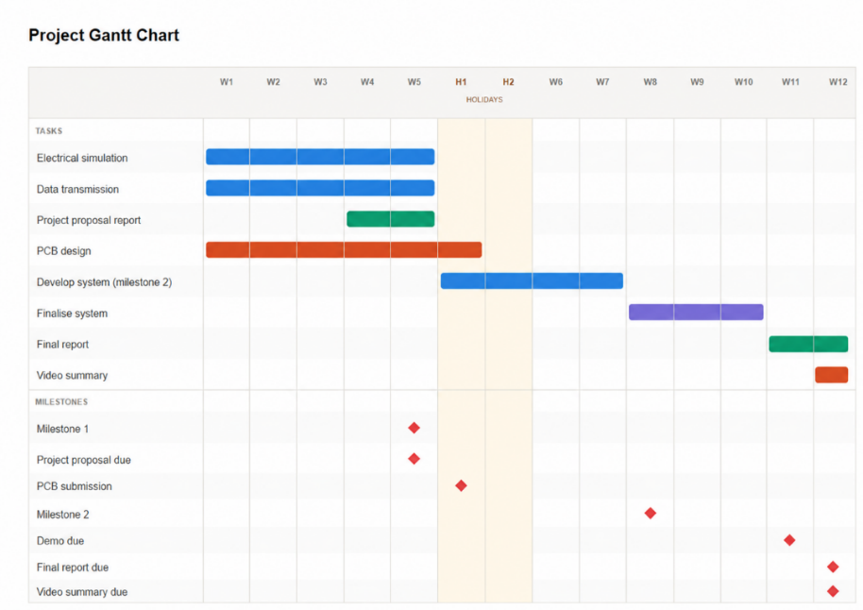
Figure C1: Gantt Chart showing progress of project

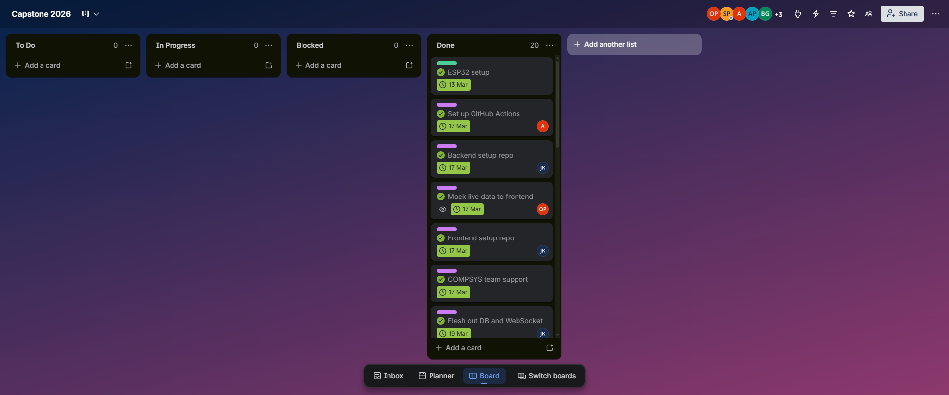
Figure C2: Kanban Board

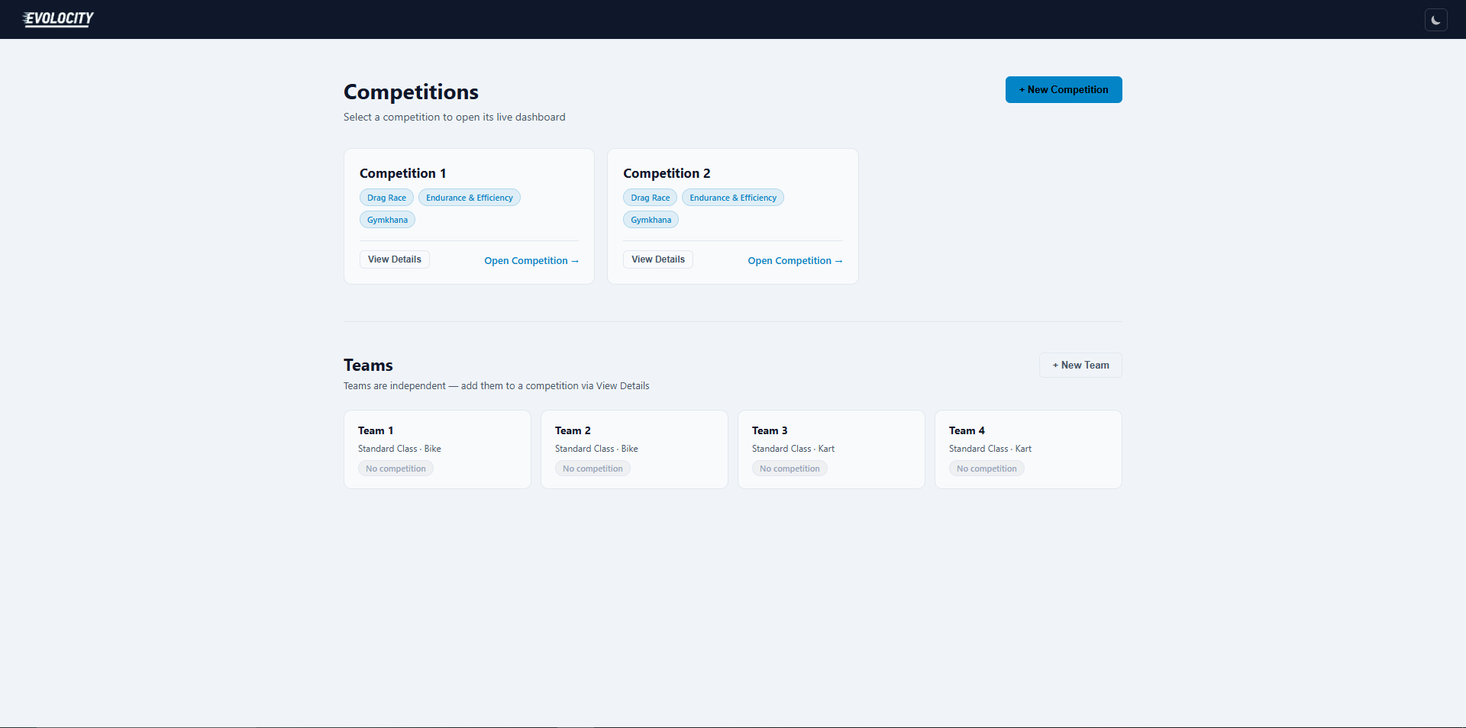
Figure D1: Home page where teams and competitions can be created

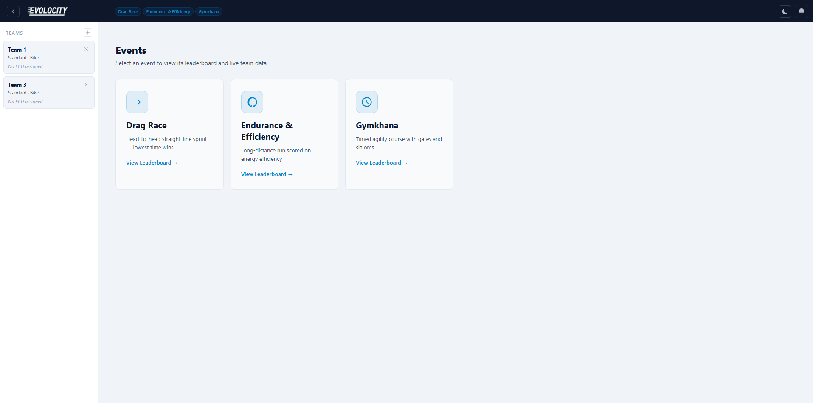
Figure D2: Competition page showing events and teams in the event

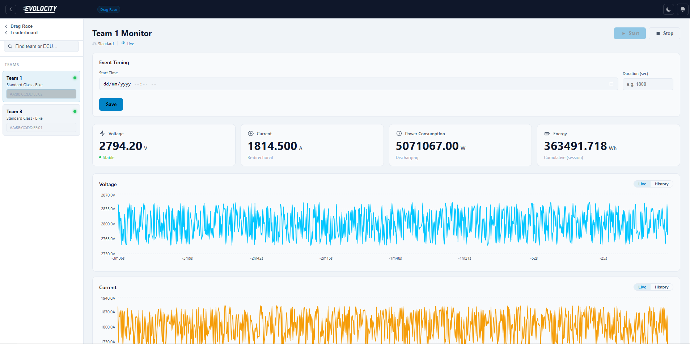
Figure D3: Team dashboard

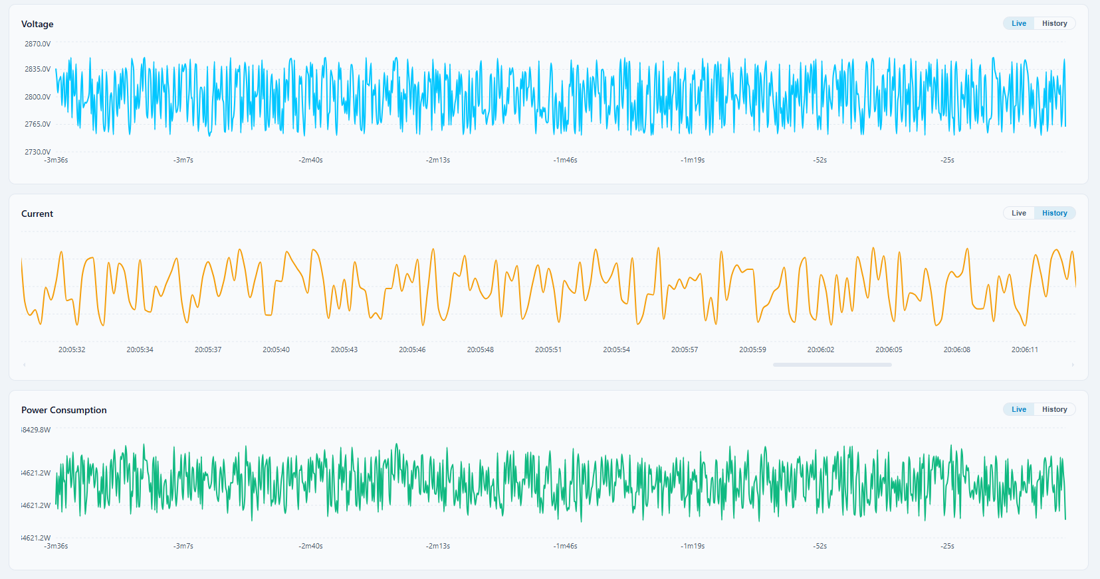
Figure D4: Live and historical graphs for each team

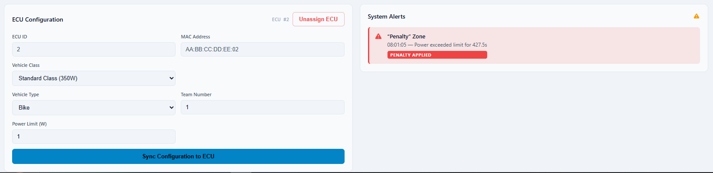
Figure D5: Team ECU configuration and Penalties

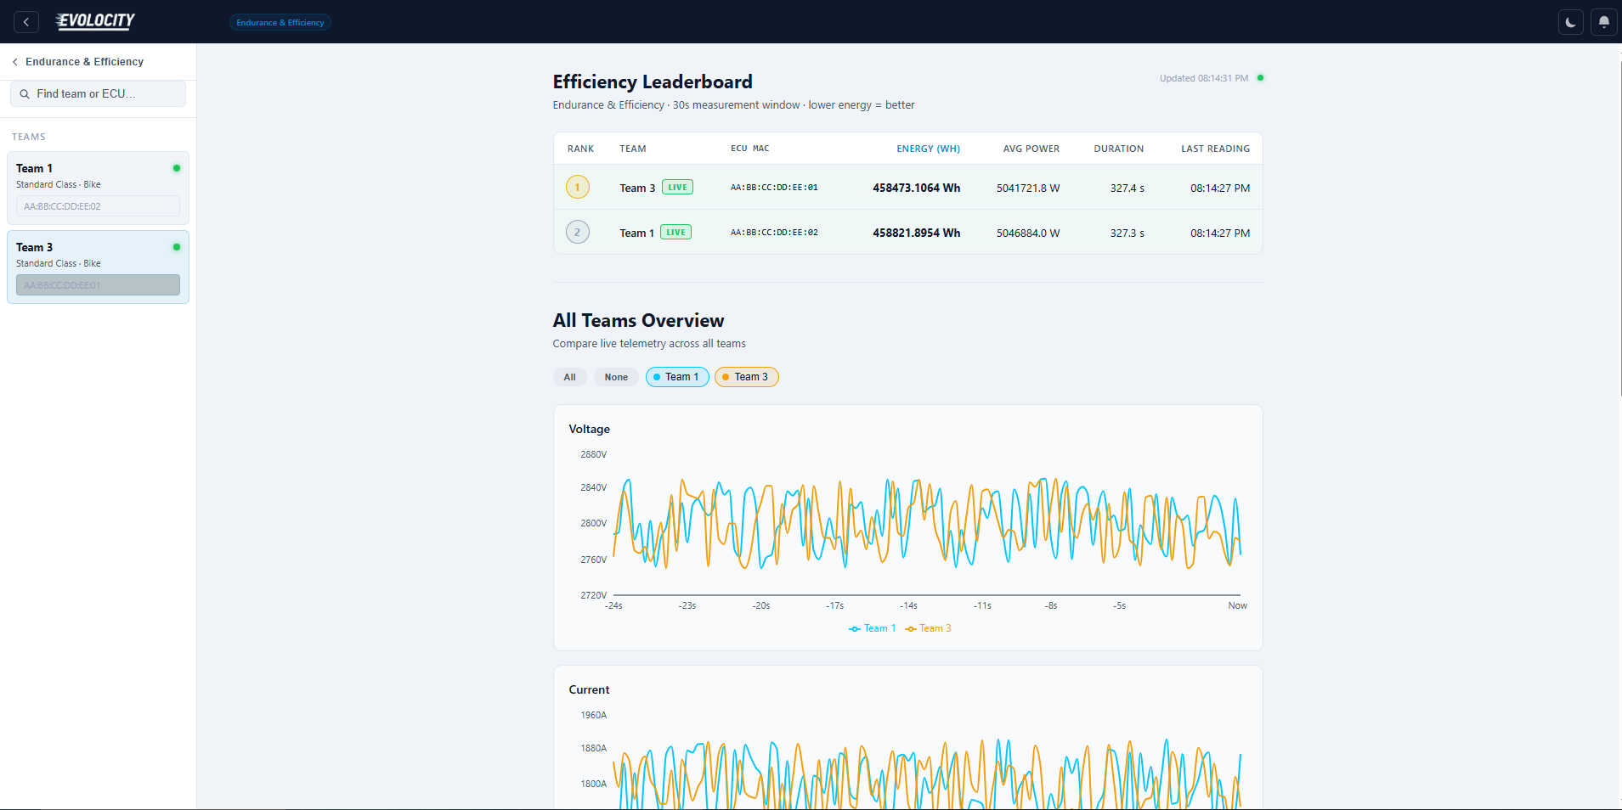
Figure D6: Efficiency leaderboard and all teams live graphs

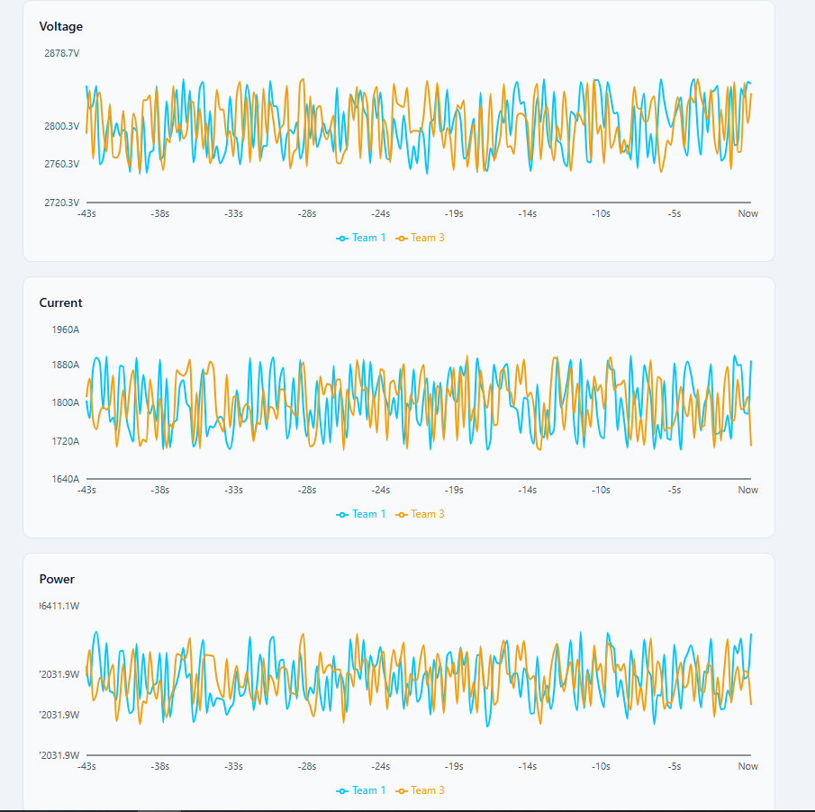
Figure D7: Multiteam live graphs

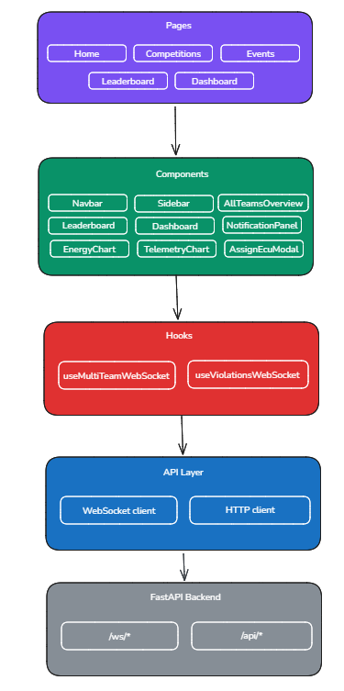
Figure D8: Frontend Design Diagram

